x

**Farmer Market School**

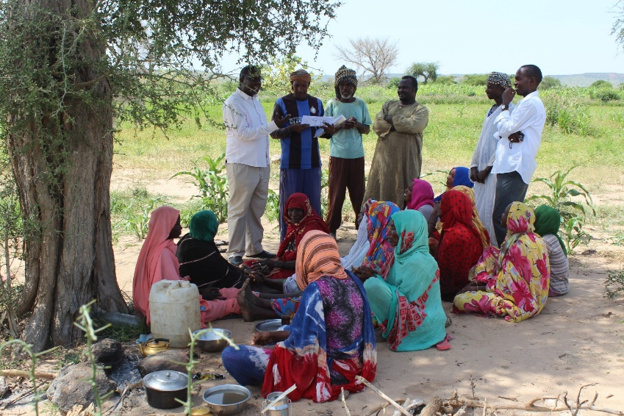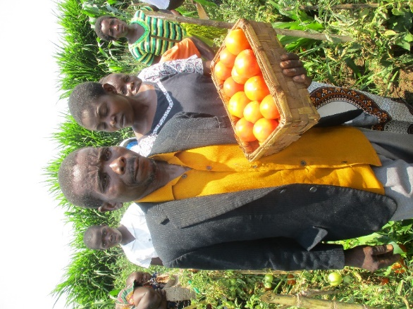

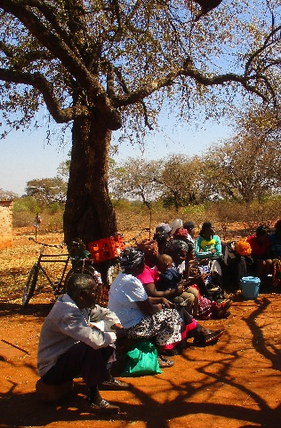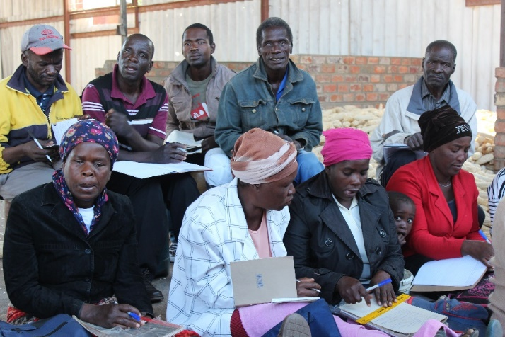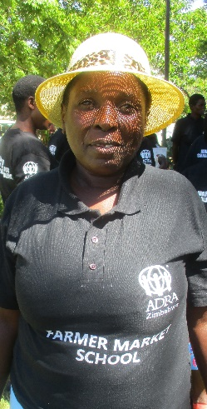

***Generic Training Manual***

**ADRA Denmark 2019**

**Table of CONTENTS**

**Introduction**  p. 4

Background p. 4

History of the FMS approach p. 5

The Family of FFS approaches p. 8

How farmers learn p.9

Organisation of the manual p.11

**A. Preparatory activities** p.14

1.Training of FMS facilitators p.15

2. Community mobilization and group identification p.16

**B. Training Sessions** p.17

1. Group formation and introduction to the learning process p.17
2. Self-monitoring tool p.19
3. Facilitation p.22
4. Household economy and the family farms p.24
5. Seasonal calendar, cash flow and savings p.27
6. Numeracy p.29
7. Market, price and payment terms p.31
8. Value addition p.33
9. Value chain map p.35
10. Communication skills p.37
11. Negotiation and contracting p.39
12. First market visit p.43
13. Preferred market crops p.45

**C. Travels along the Value Chain** p.47

1. Second value chain trip p.47
2. Third value chain trip p.48
3. Fourth value chain trip p.48

**D. Conclusion** p.49

**Bibliography** p.51

**ACRONYMS**

* ASC - Action for Social Change
* FBS – Farmer Business School
* FFS – Farmer Field School
* FMS - Farmer Market School
* VSLA – Village Savings and Loan Association
* SHEP – Small Holder Empowerment Project (JICA project approach)
* WITS – Wealth in the Soil (ADRA Australia supported project in

Zimbabwe)

* AGRITEX – Agricultural Technical and Extension Services (Zimbabwe)

**Introduction**

Smallholder farmers’ growing engagement with the market is a key precondition for increased income to farmer household and for agriculture based economic growth. But most often farmers – especially smallholder farmers - remain at the fringes of the market. They are not included in the value chains for their commodities as conscious actors, but – if at all – they are perceived as merely an economic factor or ‘input suppliers’. Typically, farmers do not know much more about the value chains than the first link they meet, which is often the middleman – much hated and demonized by the farmers, who feel that they get too low prices for what they produce.

But, to be engaged with the market requires much more than just removing the middleman, actually not necessarily a good idea, because the middleman has a function in the value chain by bringing goods from A to B, without which the chain would not function. The farmer needs market skills, must be market ready, before s/he can maneuver and benefit from what the market offers. These skills can be learned, and with those skills the farmer can start treating farming as a business.

This operational manual for Master training of FMS facilitators is a guide in how a smallholder farmer in Africa can learn to acquire such market skills and become market ready – or with another term – market or economic literate. We call this a ***Farmer Market School*** to distinguish it from the two models with related names – Farmer Field Schools and Farmer Business Schools.

**Background**

The African smallholder farmer has many negative experiences with the market. It is affecting her perception of it, and she starts looking at the functioning of the market as a law of nature. The low prices for their crops, the greed of the middleman are just unchangeable facts of life. A negative mindset embraces the smallholder farmer, who just continues producing a combination of food and cash crops to keep her family alive, hoping that at least some of her children will be able to go to school and live a better life far away from the rural poverty they were born into.

The negative mindset does not lead to action, nor to revolt. The smallholder farmer sticks to the land. Sometimes, well-meaning officials, NGO representatives visit the village and give advice and ideas. For a time, the smallholder farmers are busy with e.g. planting aloe vera, learning how to make peanut butter. But where to sell all this? Not even the middleman wants to buy aloe vera or home-made peanut butter.

Farmer Market Schools has a different effect on the smallholder farmer. In an evaluation report[1] on the FMS pilot projects in Zimbabwe and Malawi, the observation is made, that when farmers start to explore the market by themselves, they have at least five instants of ‘*Wow!-*experiences, which change their way of thinking:

The first occurs, when the farmers in an FMS group experience the facilitation process, which FMS uses. The second ‘wow’-experience occurs, when the FMS members visit the local market, which they actually have visited many times before, but discover, through systematic interviews, how different the various potential buyers of agricultural product - shop keepers, restaurants, informal market vendors - are from each other. Some require quality, others want the cheapest, some pay cash, while others need credit, some want to establish a long-term business relationship, while others want to cheat you.

As the FMS student continues exploring the market, a third ‘*wow*’-moment comes, when she visits down-stream value chain actors – maybe far away from the village – who actually invite them into their offices and treat them with respect. The smallholder farmers get the feeling that they are important. The fourth positive experience occurs, when the FMS members engage in facilitating their own peers, who have not been through FMS training. They copy the lessons they have been through, using the same facilitation skills they have been subject to. It has a profound impact on the farmer-facilitators, as expressed by John: “*being trained and working as a facilitator has been amazing*”. “*I have changed, now I communicate and have become a humble man*”[2]. The fifth moment is of outright happiness: when the FMS member gets her first payment after selling a crop in response to the requirement of specific value chain buyer.

This transformation is one of empowerment, which replaces the initial negative mindset related to the market with a positive forward looking one ultimately building the *‘I can!’* attitude. The FMS member realizes that the low prices and the frustrating experiences with selling to a middleman are not a law of nature. They can be challenged and changed.

*Theory of Change*

The rationale for this approach – its Theory of Change - is the following: Smallholder farmers are locked in a negative attitude to the market. But if this attitude can be un-locked through facilitation and discovery learning, they become motivated to continue exploring the market further. Once a value chain is known with all its links and actors, specifications and peculiarities - the smallholder farmers will be better able to make decisions about which value chains to specialize in and will know what is expected of them as producers. They will thus more easily be included in the value chain and benefit more than if they only knew the first link in the chain. Furthermore, when the producers have been able to analyse one value chain with this participatory methodology, they would have the ability to use the same method on another value chain on their own should that be necessary for them in the future.

**History of the FMS approach**

*The beginning: research farmers*

During the years 2002-8 Danida’s Agricultural Business Development project in Kenya carried out a pilot project in Kitui, Kenya using a new method to value chain development, which puts the farmers as the drivers. Some of the experiences from this pilot project were taken into use, when ADRA Malawi faced some challenges with farmer training in 2015. The Action for Social Change (ASC) project had tested the Farmer Business School approach, but ASC staff were not fully satisfied with the effect.

ASC has a bottom up approach and decided to make a small test with some farmers in the program area. Two groups of ‘farmer researchers’ were mobilised in Mulanje and Machinga Districts. The two groups were encouraged to do market research for their preferred crops. They were given very basic training in relevant market issues by ADRA, before they went to visit markets and research how their value chains functioned. The trips to market centres were paid and undertaken by themselves without project support.

At a stakeholder meeting in Blantyre in November 2015 the research farmers presented their findings. It was obvious that they had undergone a process from being almost totally market illiterate to be much better informed about how the markets for their crops functioned. The amount of data they had collected was impressive. During this meeting ADRA Denmark and ADRA Zimbabwe were present, and it was decided to take an additional step in developing this approach further under the name Farmer Market School, which was chosen with intended reference to the methodology behind the Farmer Field School approach, which FMS partly built on.

*Farmer Market School piloting*

This approach would be piloted in Malawi as cooperation between ADRA Malawi and ADRA Denmark and with funding from ‘Danmarks Indsamling’ and as an independent two-year project running parallel with the ASC program. A pilot project in Malawi got established with two new FMS groups in Machinga and two in Mzuzu. A training was undertaken by ADRA Denmark of facilitators for these FMS groups. The facilitators were ADRA staff and Ministry of Agriculture extension staff. An FMS operational manual had been written for this purpose.

Staff members from the ASC program in Zimbabwe present at the November meeting in Blantyre insisted that the approach also should be piloted in Zimbabwe. And this would be as a special component of the ASC program, which was, however, being phased out in 2016. The Zimbabwe pilot project would thus only be for one year. A similar training took place in Harare for ADRA Zimbabwe staff (ASC and WITS staff) and AGRITEX district staff plus other interested organisations. Initially 7 FMS groups were established in Matabeleland North (5) and Mashonaland East (2) Provinces, most of whom were members of irrigation schemes, and the rest had community gardens or individual plots.

*Networking*

In order to share the ideas behind the pilot project and the new FMS concept, ADRA engaged in a number of networking activities.

A stakeholder meeting was held in Lilongwe with ADRA Malawi as one of the key organisers. The subject was ‘smallholder farmers and the market’, and the ADRA Malawi FMS pilot project was presented. ADRA Denmark also made a presentation of the FMS approach at the 12th BDS conference in Kenya as well as for members of the Micro-Finance Forum in Denmark in 2017. And a stakeholder meeting was also held in Harare where the approach was presented. A short video on the FMS experience in Zimbabwe was produced afterwards, and farmers had the opportunity to share their experiences with the FMS approach.

An exchange visit was organized where the Project Manager of the FMS pilot project in Malawi visited Zimbabwe. Together with the Deputy Director from AGRITEX FMS groups were visited by a small delegation of representatives from ADRA Zimbabwe, Denmark and Malawi. An agreement was made with ADRA Australia to continue supporting the FMS groups in the Matabeleland North and Mashonaland East in its ‘Wealth in the Soil’ (WITS)-project after the phase out of ASC program.

During 2017 the ADRA Denmark FMS resource person made four presentations of the FMS approach in Sudan – one at national level and three of state level in Blue Nile, West Darfur and White Nile respectively – for stakeholders as an introduction of the idea to also pilot the FMS approach in Sudan as well. In October 2017 ADRA Denmark made a presentation of the FMS approach to an audience of members of ‘Danish Forum for Microfinance’ in Copenhagen. The FMS approach was also presented to the FAO regional offices in Eastern Africa (based in Nairobi) and Southern Africa (based in Harare). FAO invited ADRA to present the FMS approach in an FFS workshop for FAO representatives from 13 Eastern African countries to be held in Rwanda.

*FMS evaluation*

During ADRA International’s Second Annual Summit in Portugal, FMS was presented in the ADRA International Technical Learning Lab for Food Security/Livelihood. The FMS video was shown to the members of the TLL and for leading ADRA International officers as an example of innovation. The TLL decided to apply for ADRA International funding under a pilot project facility to evaluate FMS and other market focused approaches in various ADRA programs. An evaluation of the FMS in Malawi and Zimbabwe were part of the proposed activities. The funds were granted, and it was decided that the TLL Food Security/Livelihood coordinator based in the ADRA AFRO-office in Nairobi would be responsible for implementation, and that ADRA Denmark would be the operational project holder.

The evaluation in Malawi took place in November 2017 and included visits to all – now 6 – FMS groups in Malawi. The FMS Evaluation in Zimbabwe started Mashonaland East during late February 2018, and in Matabeleland North in first half of March 2018. It was conducted by a different consultant, as the consultant doing the Malawi evaluation could not finish the work due to personal reasons. A second verification visit was undertaken to Mzuzu during September 2018.

In connection with the consultant-led evaluations of the FMS experiences in Malawi and Zimbabwe, which primarily used qualitative methods, it was decided to make quantitative surveys in both countries, which would also relate to baselines established before starting the FMS groups as end-lines. The Malawi survey was undertaken in December 2017, while data processing and preliminary reporting was done in early 2018. In Zimbabwe the similar process was undertaken in January-February. In both countries these surveys were undertaken by relevant ADRA staff and MOA-field staff used as enumerators.

*Findings and Recommendations*

FMS is described as ‘*an innovative new attempt of marked linkage intervention’*. Through more than 50 interviews the evaluation identified four different indicators of perspective transformation among the FMS facilitators and the FMS members: *‘increased individual confidence and emancipation; changing household agency and gender relations; social relations within the FMS group; and visibility and status in community’.*

The report also focused on some shortcoming and challenges, which were turned into recommendations on how FMS could be improved. The most important recommendations were dealing with how FMS can be consolidated and further developed as a concept and scaled up institutionally. The recommendations include the following*:*

* Planning for a three-level facilitation process instead of the initial two-level approach. This means that 1st level is Master training of selected FMS facilitators – ADRA and Government extension staff, level 2 is when these facilitate FMS for farmer group representatives, and the 3rd, when these FMS members facilitate the other farmers in their groups. This will mean more emphasis on learning the facilitation skills and how to use them in the initial Master training.
* In the training curriculum - the issue of farmer organization for collective marketing should be introduced, measures should be developed to ensure social inclusion in the mobilization of FMS members. The recommendations also included some more technical issues to be included in the manual, which were discovered during evaluation process: pre-market handling of perishable vegetables and how to make FMS more relevant for rain-fed agriculture
* Finally, recommendations were made regarding how to institutionalize implementation of FMS in East and Southern Africa. FMS should thus be regarded as a new member of the family of FAO supported approaches, Farmer Field Schools, Pastoralists Field Schools etc. But FMS should also be upscaled as an ADRA approach, with the ADRA AFRO office housing an FMS knowledge and learning hub.

All these issues are sought addressed in the present manual, which has a wider scope than previous versions. It thus is seen as a first Master training manual, which goes a bit deeper in all the subjects and puts more emphasis on making master trainers able to train farmer facilitators, who can facilitate other farmers. Initially, FMS trainings were typically done over one full week. The new level one Master training will be of 2 full weeks, while the training at the two next levels will follow a longer course of parallel weekly farmer meetings over 3-5 months.

The project ‘Wealth in the Soil’ (WITS), which supported the FMS groups after the initial pilot project was completed – up to mid-2018 – has also been evaluated. The evaluation report’s findings show that FMS has indeed had *‘built confidence and capacity in targeted farmers, thereby improving access to markets and increasing family incomes as further confirmed in the farmer testimonies below’.*

The evaluation report presented a big number of beneficiary testimonies and case stories based on key informant interviews. One of these were about Itai Gava from Chinyika Irrigation Scheme in Goromonzi:

*‘Itai is now regularly producing baby marrows, cabbages and carrots for Brands Fresh and Food Lovers. In his first cycle of fresh produce to these two markets, Itai realised more than $800 in sales. Before the FMS training, he was amongst the Chinyika Irrigation Scheme farmers who would produce green mealies and leafy vegetables for the local market or delivery to Mbare Musika. Now the farmer even rents plots from other farmers producing first grade for Brands Fresh and Food Lovers then sells the remainder to the local markets. At the time of the evaluation, Itai was selling cabbage and broccoli to Food Lovers and Brands Fresh at a price of between $1.50 and $2.00 per kilogram. He also had 0.4 hectares of butternuts (Waltham) and 600 plants of baby marrow (Amanda) that was almost ready for the market’*.

**The family of FFS approaches**

The evaluation of FMS in Malawi and Zimbabwe showed that smallholder farmers need complementary knowledge for production, business and market. ‘*The FMS is closely related to the well know FFS and FBS approaches and the three approach a complementary rather than competing or overlapping in scope’[3]*

*Farmer Field Schools*

The Farmer Field School (FFS) approach is being widely used as an alternative to other agricultural extension/training methods for smallholder farmers. FFS focus on

* introduction and local application of new or better farming technologies
* development of a participatory learning environment
* innovation
* group development

The FFS approach is well known by most development agencies involved in agricultural development. It is strongly promoted by FAO and supported by many agricultural ministries in the developing countries. Its strength is the strong focus on farmer empowerment and its facilitative approach. However, the classical FFS approach does have some limitations in relation to improving livelihoods of smallholder farmers. The FFS focuses more on technology and productivity than on farmers’ economy. And it tends to focus on production only, not marketing of the crops produced. *‘The lack of assistance to respond to farmers demands in terms of market facilitation provides a great challenge for FFS groups and networks in changing from subsistence farming to a more commercialised farming’ [4].* Furthermore, there is also a tendency of some FFS trainers to be directive instead of facilitative, which may impede the mutual learning process.

*Farmer Business Schools*

This has led to a growing focus on economics and business thinking into of farmers by promoting the concept of ‘farming as a business’ New metthods have been suggested, for example Farmer Business Schools’(FBS). The Farmer Business School approach has been adopted and promoted by some agriculture ministries and development projects. Malawi is one such country, where the Ministry of Agriculture has started the promotion of Farmer Business Schools from 2009. Very elaborate manuals have been produced – a farm business school manual and a FBS training manual - for training farmers[5].

The FBS manuals like other business training approaches primarily focus on learning the business economics of the individual farm enterprise. The FBS manuals offer a comprehensive training program, but with only a small section on marketing.

**How farmers learn**

How should the smallholder farmers learn about the market?

The FBS training manual suggest a list of relevant subjects e.g. the advantage of collective marketing, on bargaining, on making market contracts. But these subjects are taught in a formal ‘school setting’. So, the farmers land in a learning situation, which departs from the basic Farmer Field School approach, where the farmers learn together, from each other and from actually practicing on their own farm. Theoretical learning situations do not appeal to smallholder farmers.

The FMS approach aims at retaining the FFS learning approach, but now applied to the market: *the smallholder farmers will discover the market by themselves.*

While the market section in the FBS curriculum is limited to visiting the nearest market places, it will in Farmer Market Schools be extended to visiting the whole value chains before making production decisions. The farmers will literally travel along the various value chains to meet the value chain actors, communicate with them to get all the information they require to make their own production decisions. Experiences – e.g. from Kenya[6] and Malawi[7] – show that smallholder farmers are able to analyse complicated market issues, which enables them to compare several value chains. While value chain exploration in Kenya was done by consultants, who assisted the farmers, the smallholder farmers in Malawi and Zimbabwe did the full exploration themselves.

This is a participatory and interactive learning approach, which is very similar to that of Farmer Field Schools and e.g. REFLECT. The farmer takes the lead and collects information. She will not be told that this or that crop is good for the market, but will make that assessment herself. It is important to stress that this is only the beginning of a process, where farming as a business is gradually mastered.

Once a market crop has been identified by the farmer, she will have new needs for information, organisation and training. These can include both more basic business training, e.g. costing, bargaining, but also a new focus on production and productivity. With relatively small holdings, the smallholder farmers can optimize earnings by increasing productivity. There will thus maybe be a demand for farmer field school, which test varieties and technologies for the production of the agreed crop.

The small quantities that one farmer can produce will also make farmers realise that they need to organize themselves to bulk their products, negotiate together, organize transport etc. in order to live up to market demands. The interactive training method should be retained as far as possible. Because that is how adults learn!

*Facilitation*

Facilitation requires specific skills. Several studies have shown that the success of a participatory approach with poor people to a large degree depends on the quality of the facilitator.

A FAO publication on FFS in Zimbabwe defines the role of extension workers as facilitators, not teachers: ‘*The role of the extension worker is that of a facilitator rather than a conventional teacher. Once the farmers know what they have to do, and what they can observe in the field, the extension worker assumes a different role, only offering help and guidance when asked. Presentations during group meetings are the work of the farmers and not the extension worker. Members of each sub-group present their findings to their fellow school members. The extension worker may take part in the subsequent discussion sessions but as a contributor, rather than leader, in arriving at a consensus on what management action should be taken’[8].*

Teaching is to a large extent based on the assumption that the teacher has knowledge, while the farmers are ignorant. This is far from the reality. Farmers have a lot of knowledge and experience. But, facilitation is not the opposite: that the farmers know everything, while the facilitator is a neutral coordinator or mediator, who adds nothing to their knowledge. To be a facilitator requires a good deal of insight in the subjects discussed. A facilitator is not neutral, but creative and motivating. Between teaching and open-ended facilitation there is a middle, where the value of facilitation comes to its right.

Facilitation is to a very large degree based on **people skills**, being:

* able to motivate farmers to speak up, not least female farmers
* appreciative of all views, also without necessarily agreeing with them
* turn challenges raised back to the farmers and ask them how they feel these challenges should be met
* rephrase questions so they are understood
* able to gauge the mood of the farmers and take initiative to change subject, have a pause or an energizer to get the vitality back, if the mood is gloomy or passive

*Farmers as facilitators*

In the quotation above on Farmer Field Schools, the facilitators are the extension officers. But, that has proven to be a difficult and restrictive way of spreading the FFS approach. For many reasons, one is that there are too few extension officers to meet the potential for upscaling the FFS approach. Another is that extension officers may not have the appropriate facilitation skills.

Therefore, farmers have with some success been trained to be facilitators and lead other farmers during an FFS. It has been found that in many cases the farmer facilitators even perform better than the government extension facilitators, provided that the selection of farmer facilitators is good. Another advantage of farmer facilitators, is that they are attached to the farmer groups being facilitated, which means that apart from being involved in starting new FFS, they also play important roles in supporting their own group activities.[9]

For the farmer Market Schools, something similar happens. First some project field staff, extension workers or other resource persons are trained as FMS facilitators. The take the training to farmers, who represent various already existing groups. These farmers, who have been trained, bring what they have learned back to their groups and actually train them by copying the all the FMS training sessions. This thus becomes a three level Training of Trainers. This spreads the market knowledge to a reasonably big number of farmers, who can take action together.

The three-level FMS training looks like this:

**Master Class FMS training by ADRA**

**FMS facilitator**

**FMS facilitator**

**FMS facilitator**

**FMS facilitator**

**FMS facilitator**

**Farmer Market School** with

farmer group representatives

**Farmer Market School** with

farmer group representatives

**Farmer Market School** with

farmer group representatives

**Farmer Market School** with

farmer group representatives

**Farmer Market School** with

farmer group representatives

**Farmer Facilitator training members of own group**

**Farmer Facilitator training members of own group**

**Farmer Facilitator training members of own group**

**Farmer Facilitator training members of own group**

In relation to numbers, the first level – Master training – max. 20 FMS facilitators will be trained. At the second level these will pair up and each pair will be able to facilitate 2 Farmer Market Schools per year (the first year). If each FMS has 20 students and they represent ten groups (having sent two representatives each to the FMS), these 20 FMS students will now function as farmer facilitators for the remaining members of their groups. Assuming that each group has 22 members, the maximum of farmers trained during a year will be 220 farmers.

**Organisation of this manual**

This generic FMS manual will be used at all the three levels mentioned above with the exception of the first level – the Master training. It will contain a number of notes that go deeper in some subjects than necessary at the farmer level. This is to give the master trainers a solid background.

All subjects will be dealt with in a farmer friendly version – e.g. the household economy tree. But some of the theories behind the subject will be part of the master training. These parts, which are only dealt with at master training will be clearly demarcated. The core manual for farmer training is the practical guide for FMS facilitators at the second and third level is much shorter. It can be printed out from the electronic version of the combined Master and Farmer training guide by deleting the demarcated Master training notes. This Farmer training guide is in English and it is generic. It should be translated into the language used by the farmers involved, e.g. Arabic in Sudan. And it should also be adapted to the national context, e.g. by making all examples on prices, volume measurements understandable for local farmers.

The manual will guide the FMS facilitator, who is responsible for facilitating the process of farmers’ learning. The phases are outlined in this guide in logical order. While the participating farmers experience an increasing learning curve and become more and more confident to engage with markets, the FMS facilitator’s role will also gradually change from being a facilitator to being an observer, and finally an adviser, who can be called in when needed and demanded by the farmer group.

The learning by members of this type of Farmer Market Schools is planned for one year – or more precisely – one agricultural cycle. But, the cycle does not start with planting season. It is the other way around: It starts with market analysis and ends with production followed by selling.

There are four parts of this manual: A is for preparatory activities, B is a number of sessions on basic business ‘theory’ necessary to grasp and equip the farmers with skills on how to analyse the market. C is the practical part, where farmers travel along the value chains of their priority crops. D. is for conclusion, Monitoring and evaluation. The manual has been tried in practice and undergone changes based on learning what works, and what does not – and also: what is needed and what is not.

The timing is roughly the following:

1. Preparatory activities – take place over **1 to 2 months**
2. ‘Theoretical’ sessions – take place as a **12 half-day session per week for 3-4 months.** There are two additional sessions, which are not mandatory, but could be included upon request by the farmers – either at this or a later stage in their development.
3. Travels along the value chain for discovery learning – these travels take place immediately after B and may contain several travels depending on preferred crops and the responses by the various market actors. Three travels will ideally be completed **within 2 months**. They are fully the responsibility for the trainees themselves, while the FMS trainer now becomes an observer
4. Conclusion with evaluation and graduation – this a rather open part of the process. Self-monitoring will be done annually, further sessions will be undertaken upon request and needs expressed. Graduation can be undertaken at a convenient time **within the first year**, after the completion of A, B and C.

**The structure of a Farmer Market School training**

|  |  |
| --- | --- |
| ***Subjects*** | ***Duration*** |
| 1. **Preparatory Activities** |  |
| 1. Training of facilitators | 3-5 days |
| 1. Community Mobilisation & Group Identification | 3 weeks |
| 1. **Sessions on basic business** | **‘theory’ (by facilitator)** |
| 1. Group formation and introduction to the learning process | Half day |
| 1. Self-monitoring tool | Half day |
| 1. Facilitation | Half day |
| 1. Household economy and the family farm | Half day |
| 1. Seasonal calendar, cash flow and savings | Half day |
| 1. Numeracy | Half day |
| 1. Market, price and payment terms | Half day |
| 1. Value addition | Half day |
| 1. Value chain map | Half day |
| 1. Communication | Half day |
| 1. First market visit (local market) | 2 Half days |
| 1. Preferred market crops | Half day |
| 1. **Travels along the value** | **chain (interactive)** |
| 1.a. Second Trip - preparation | Half day |
| 1.b. Market visit | Half to full day |
| 1.c. Follow up meeting after market visit | Half day |
|  |  |
| 2.a. Third Trip - preparation | Half day |
| 2.b. Visit to market town/city | Two days |
| 2.c. Follow up meeting after market town visit | Half day |
|  |  |
| 3.a. Fourth Trip - preparation | Half day |
| 3.b. Visit to market town/city | One day |
| 3.c. Follow up meeting after market town visit | Half day |
| 1. **Conclusion, Monitoring &** | **Evaluation** |
| Conclusion, self-monitoring and evaluation | Half day |
| Facilitator report writing (compulsory) | One week |
| Post-harvest monitoring session | Half day |
| Graduation with presentation of FMS experience in a public meeting (optional) | Half day |

|  |
| --- |
| 1. **Preparatory Activities** |

**A.1 Training of FMS facilitators**

The master training aims at preparing FMS facilitators to conduct Farmer Market Schools, where the students themselves become facilitators of their peers.

**The master training**

The master training has three elements:

1. Training in facilitation skills
2. Training in basic theory and skills needed for understanding how the family farm works as a business entity, how the markets and value chains work and how trust is built between market actors through communication skills.
3. Monitoring and documentation of process-oriented training

A Master training course is for two weeks.

**Week one**:

* Introduction to FMS
* Adult learning and Facilitation
* Organising farmer training based on a facilitatory approach – the logistics, planning, execution
* Preparing and undertaking mobilization meetings
* Sessions 1-5

The training in the different sessions is organized as learning the theory and facilitation skills at the same time. The participants will turn-wise facilitate the different subjects while the other trainees will be students. All sessions will be evaluated by the participants

**Week two** will focus on:

* Sessions 6-12
* Travels along the value chains – experiences, challenges, logistics
* One full day the trainees will themselves explore value chains, interview market actors and document their findings
* Monitoring – how to use the self-monitoring tool
* Relationships to other approaches in the FFS-family: Farmer Field Schools, Farmer Business Schools, Pastoralist Field Schools
* Graduation with issuing of FMS master certificates

The trainees, who participate in the FMS Master training must have some experience with facilitation and adult learning, FFS/PFS or other agriculture/livestock extension approaches, and they must have some insight into how markets work, ideally having been involved with FMS already. Their education level should be agricultural college, university level. Good English written and spoken skills, fluency in local language from their country of work – also written and spoken. General computer skills, including Excel.

The Master training will take place in well-equipped rooms with space for 25 people and with access to break-out group meetings. There will be stationary, projector, flip-carts, wi fi available, The environment will be friendly and accommodative, in a city with access to green areas and fresh air. It will not be in the rainy season. Most sessions will take place indoors. It is a semi-long training, so there will be room for social activities and leisure in evenings and week-ends. There is a weekend in the training - Saturdays and Sundays – with no formal workshop meetings. Fridays may be short. There will most likely be ‘home work’ in evenings and the weekend.

**The FMS training of farmers**

Both levels of FMS training of farmers will take place over a longer period – close to a full year - as outlined above. This training will take place in the rural areas at an agreed venue. The exact logistics for this training will be described in the section B.

**A.2 Community mobilization and group identification**

The aim: to introduce the FMS approach and identify motivated groups who want to participate in a Farmer Market School. This may take at least three weeks. The driving force and main motivation for smallholder farmers to join a Farmer Market is – and should be – ‘***making money!’***

**Sensitization of Government**

If Farmer Market Schools are being introduced into a country, a state or even a district it is important to have some initial meetings with the most important stakeholders at that level. It would e.g. not be a good idea to introduce FMS as aa new approach in a country without meeting the Ministry of Agriculture and other key stakeholders, such as the national FAO office.

When FMS was introduced in Sudan such stakeholder meetings were held at State level in West Darfur, White Nile, Blue Nile as well as in the national Food Security cluster forum. These stakeholders are important throughout the process of developing the FMS in a country or a State/Region.

**Community meetings**

As for Farmer Field Schools the ideal size of a Farmer Market School is 20 to 25 persons. The FMS members would ideally be part of an existing farmer group - farmer club, farmer interest group, cooperative or farmer association. It may be 2 or 3 members of an existing group, who take part in the FMS.

Mobilisation meetings thus target communities with existing farmer groups, who are typically known by the Ministry of Agriculture, but do not need to be registered formally. The groups can include farmer clubs, farmer interest groups, farmer field school groups, farmer cooperatives, irrigation scheme members and farmer associations.

The opportunity of joining or becoming a Farmer Market School will be announced in the district in collaboration with the District Agricultural Office. It is important to hold some information meetings, where the FMS is explained in more detail so that interested members know what they can expect beforehand.

There are three possible kinds of community meetings necessary

**i. Preliminary meeting with community leaders**

**Having identified the community to work with for the FMS, a meeting with community or traditional leaders is arranged. The master trainer together with local administration leaders explain about the content and scope of FMS. All the practical and logistical aspects must be explained in detail, e.g. number and duration of meetings, the self-payment required**[10]**. Support from community leaders will go a long way in mobilizing community participation.**

**ii. Sensitization of community members**

Having been sensitized on the FMS, the community leaders then call for the wider community meeting. At this meeting, community members are oriented on the concept of FMS with much details such as: how it is implemented, how long it should be implemented, role and responsibilities of facilitators, roles and responsibilities of the FMS participants. At the end, the community members are asked, whether they are ready and willing to take up the concept. Having accepted to implement the FMS concept, another meeting is arranged for the identification of FMS participants.

**iii. Identification of FMS participants**

**The FMS community mobilization encourages the respective communities only to appoint participants of the FMS approach, if the person appointed will be fully backed by the community in general and his/her organization (farmer club, association, Farmer Field School, irrigation scheme etc.) in particular. This is so, because the FMS approach requires financial contributions for the individual FMS members’ training. There is only minimal or no external financial injection into the FMS implementation for sustainability’s sake. If a person, interested in joining an FMS training, but has no organizational backing, he/she may volunteer on the understanding that he/she pays her own training costs. The funds are meant to cover market visits, which are part and parcel of FMS.**

***Social inclusion* is an important aspect when mobilizing and identifying FMS participants. Measures to strengthen social inclusion:**

* **Encouraging FFS groups and other types of groups with a membership of smallholder farmers who belong to the middle and lower social strata**
* **‘Access to land’ for members should not be used as a discriminating factor. ‘Access’ includes user rights of various forms, even lease and share cropping**
* **Rain-fed farming should not be discriminated against, compared to irrigation farming**
* **People engaged in other types of production than farming – e.g. livestock, fruit trees, basket weaving – can also benefit from FMS training**

**It is furthermore important, when FMS members are being selected by their groups, that these members are**

* **Willing to volunteer their time towards FMS activities**
* **Willing to attend all the planned trainings**
* **Willing to take on the responsibility of facilitating the knowledge learnt during the training to his/her group members**
* **Willing to travel along the value chain of preferred crops, which could include overnight stays**
* **Willing to function as a resource person in his/her group and community on matters dealing with market access and information**
* **Willing to wear an FMS T-shirt that indicates that he/she is an FMS farmer facilitator**

**After these community and farmer group meetings a list of names of interested participants is made with their contact telephone numbers. And the venue for the first FMS meeting is agreed. There will be local transport issues for most members. It cannot be assumed that all members come from the same village. These transport issues need to be agreed. Maybe it is better to have two FMS groups with each 12 members than one with 24, if it eases transport. As a principle for good group learning, membership of an FMS group should be at least 18 and not more than 25. So, if transport issues speak for two smaller FMS groups, the members will be urged to increase their membership.**

A place is required for meetings of around 20 participants, who then become the Farmer Market School. It must be explained clearly to prospective group members that apart from time spent in meetings and at trips, the participation also includes visits to trade and urban centres, which cost money that the group has to raise by itself. The only thing free is the trainer/facilitator and the training materials.

|  |
| --- |
| **B. Sessions on basic business ‘theory’** |

**Session 1: Group formation and introduction to the learning process – the first meeting with new FMS Group**

The aim of this first session of the Farmer Market School with the facilitator is to set the learning environment, give an overview of the content and the phases of the learning process and to agree on a timetable.

1. **Welcome**

* Welcome to participants by facilitator (and possibly an MOA representative)
* Self-introduction of all participants and climate setting

(Duration 30 minutes)

1. **Expectations**

Participants talk in pairs for five minutes and each pair express two expectations they have to the Farmer Market School. These will be noted down or drawn on flipcharts by the co-facilitator.

(Duration 30 minutes)

1. **Introduction of the course of the school**

The facilitator goes through the program with all its sessions – their content and duration. The facilitator explains why and how theory and practical experiences are mixed – the aim is that everybody learns. Theory is there to help practice, and practice to contribute to theory!

(Duration 30 minutes)

1. **Workshop structure**

The workshop needs to be structured with rules, practical set-up and how to assure that everything goes well

* The following issues are discussed and agreed upon
* A list of ‘Dos’ and ‘Not Do’nts’ is made in the plenary and agreed upon
* The workshop design and setup may need to be altered for optimal learning. A group of 2-3 volunteer ‘interior designers’ will make the necessary changes during the next recess
* A time keeper is selected and rules for late-coming to sessions agreed
* A monitoring group will at the end of each training day monitor the general mood of the members. (A mood meter template is shown).

(Duration of workshop structure 30 minutes)

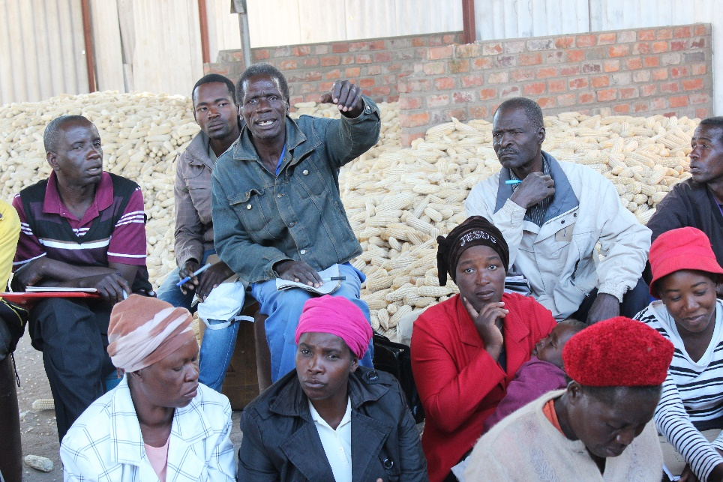

1. **Selection of Leadership Committee**

The FMS committee consists of a chairman, a secretary and a treasurer. The purpose of the

committee is to:

* Coordinate the learning activities of the FMS class
* Liaise with relevant stakeholders
* Be the contact persons for FMS class
* Ensure that information from the FMS class is being passed on to the farmer groups
* Network with other FMS class representatives in other areas to share information, coordinate production and marketing, facilitate exchange visits, etc.
* Fund-raise for group activities – including transport to market visits. The treasurer should keep a safety box and ledger
* Secretary should keep a log book/’jotter’ where s/he records information from the FMS training – including participation and action points
* Agree on timetable: How often should the FMS group meet? If weekly, which weekday? How long should the session be? Where should the FMS group meet? Should there be food/tea? Who will make it?

(Duration of this session 1 hour 30 minutes)

**Total duration of Session 1 is 3½ hours**

**Session 2: The self-monitoring Tool**

The aim of this session is to make the FSM members understand the value of monitoring and to introduce the FMS self-monitoring tool

**1. What is monitoring?**

Example: Two farmers growing maize



The cartoon is drawn on a flip chart in advance and is presented in the plenary. Members are asked to comment on what happens in a plenary sharing session.

(Farmer 1 regularly checks the plants growing in his fields. When he notices that some plants are diseased and are becoming stunted, he immediately treats them with a (biological!) remedy. His harvest is good, and he is satisfied. Farmer 2 does not look at his field while the crop is growing. At harvest time he is shocked when he realizes that most of' the crop is lost. He is disappointed.)

Conclusion: *this is monitoring!*

(Duration 20 minutes)

**2. Self-monitoring tool introduction**

This small exercise above is used to illustrate the importance of monitoring as an introduction to the self-monitoring tool.

This tool is explained in detail – with some examples - to the FMS trainees (written on a flip chart). They are then each given a copy of it, where they will individually insert their own data for the previous cropping season. It is mandatory for every member of an FMS class to monitor his/her farm’s production from before the training and afterwards.

The participants work individually on their own chart (30 minutes). Then they pair up and explain their figures to each other. This will undoubtedly lead to some questions, which the facilitators address by moving around from pair to par. (Duration 60 minutes).

Self-monitoring tool for FMS members (Sudan[11])

|  |  |  |  |  |  |  |  |  |  |  |
| --- | --- | --- | --- | --- | --- | --- | --- | --- | --- | --- |
| **Farmers name:** | | |  | | | **Village name:** | |  | | |
| **FFS/FMS group name:** | | |  | | | **Date:** | |  | | |
| Crop and season | Area planted (fedhan) | Rainfed or irrigated | | Monocrop or intercropping (M or I) | Quantity harvested (Kg) | | Quantity sold (Kg) | | Unit Price (SDG) | Total price (SDG) |
|  |  |  | |  |  | |  | |  |  |
|  |  |  | |  |  | |  | |  |  |
|  |  |  | |  |  | |  | |  |  |
|  |  |  | |  |  | |  | |  |  |
|  |  |  | |  |  | |  | |  |  |
|  |  |  | |  |  | |  | |  |  |
|  |  |  | |  |  | |  | |  |  |
|  |  |  | |  |  | |  | |  |  |
|  |  |  | |  |  | |  | |  |  |
|  |  |  | |  |  | |  | |  |  |
|  |  |  | |  |  | |  | |  |  |
|  |  |  | |  |  | |  | |  |  |
|  |  |  | |  |  | |  | |  |  |
|  |  |  | |  |  | |  | |  |  |
|  |  |  | |  |  | |  | |  |  |

**3. How to use the self-monitoring tool**

An example for two crops is now shown, with figures from present season compared to those of the previous season.

|  |  |  |  |  |  |  |  |  |  |  |
| --- | --- | --- | --- | --- | --- | --- | --- | --- | --- | --- |
| **Farmers name:** | | | *Ali* | | | **Village name:** | |  | | |
| **FFS/FMS group name:** | | |  | | | **Date:** | | *2017* | | |
| Crop and season | Area planted (fedhan) | Rainfed or irrigated (R or I) | | Monocrop or intercropping (M or IC) | Quantity harvested (Kg or bag) | | Quantity sold (Kg) | | Unit Price (SDG) | Total price (SDG) |
| tomato | ½ | I | | M | 120 kg | | 100 kg | | 5 | 500 |
| sesame | 1 | R | | M | 20 bags | | 20 bags | | 50 | 1000 |

|  |  |  |  |  |  |  |  |  |  |  |
| --- | --- | --- | --- | --- | --- | --- | --- | --- | --- | --- |
| **Farmers name:** | | | *Ali* | | | **Village name:** | |  | | |
| **FFS/FMS group name:** | | |  | | | **Date:** | | *2018* | | |
| Crop and season | Area planted (fedhan) | Rainfed or irrigated  (R or I) | | Monocrop or intercropping (M or IC) | Quantity harvested (Kg/ bag) | | Quantity sold (Kg/bag) | | Unit Price (SDG) | Total price (SDG) |
| tomato | ½ | I | | M | 100 kg | | 80 kg | | 6 | 480 |
| sesame | 1 | R | | M | 25 bags | | 25 bags | | 60 | 1500 |

This simple example is done in plenary. The participants discuss what the difference has been from first year to second year. The exercise is repeated, where pairs jointly insert figures from present with those of previous season. (Duration 60 minutes)

**4. Introduction of the self-monitoring exercise book**

At the end of the day all participants are given an exercise book with multiple pages with the empty monitoring sheet pre-printed on every second page. Every other page is blank and can be used for calculations.

The exercise book is briefly explained. Every member will fill her/his own figures and keep the exercise book, but she/he will do this at her/his own time. The FMS member will bring a bunch of books back to the farmer group he/she is a member of and will introduce the tool to all the farmer group members.

(Duration 15 minutes)

**Total duration of Session 2 is 3 hours**

**Session 3: Facilitation**

Aim: to understand the difference between adult and child learning and of ‘teaching’ and facilitation

**1. Identification of the key actors in the FMS approach**

Exercise: Group work. Two groups answer question a, and two groups answer question b.

1. What are the characteristics of a smallholder farmer?
2. What are the characteristics of a vendor or middle man?

The groups present their findings on flip charts and they are discussed

(Duration 45 minutes)

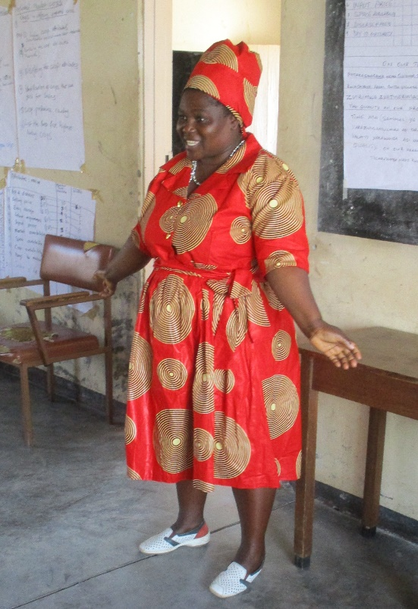

**2. What is the difference between a teacher and a facilitator?**

The facilitators make a brief introduction to this question by telling that they are not teachers, but facilitators, and that during the FMS members will also learn how to become good facilitators. A role play is organized, which compares a facilitator with a traditional teacher

The FMS members are divided in two groups, one will make a role play showing a traditional teacher, the other a facilitator. One person in each group is either facilitator or teacher, the rest are students.

In the first role play the students sit down, are quiet. Only the teacher speaks, and a student will only speak if the teacher asks a question. The group will choose a subject the teacher will teach. The students sit in lines facing the teacher, who is having a stick, which he uses to explain things written on his ‘blackboard’. The teacher will ask questions and will respond whether the answer is right or wrong.

In the second role play the students sit in a circle and the facilitator has no stick. The facilitator will ask questions on the chosen subject, will listen to the answers, not being judgmental. The students will comment on each other’s answers and ideas, while the facilitator will sun up the discussion at the end.

After the two plays the students are all FMS students again. They discuss the two role plays and point at the differences between the two styles of teaching. The difference between how children and adults learn is touched.

(duration 60 minutes)

**3. Adult learning**

Four groups are formed. Two groups discuss: *‘How do adults learn’*, the other two: ‘*What are the characteristics of a good facilitator’.*

After discussing in the groups for 30 minutes, the four groups present their findings one by one (10 minutes each).

After each presentation there is feedback from the other students.

(duration 70 minutes)

**4. Facilitation practice**

The students are now told that all the next sessions will be presented by themselves, so that they learn how to facilitate. They will have to read through the manual beforehand and prepare presentations. There will always be two students together. One will facilitate, while one will be co-facilitator. The roles will change during their presentation. They will also prepare that the facilities are present, organize group work and plenary discussions.

The first eight volunteers will pairwise facilitate the next sessions: household economy, seasonal calendar, stress and shocks, savings.

(duration 10 minutes)

**Total duration of Session 3 is 3 hours 20 minutes**

**Session 4: Household Economy and the ‘Family farm’**

**1. Household Economy**

Aim: To understand the central importance the household economy and seasonal income and expenditure plays for smallholder farmers

1. *What is a household?*

Suggest definitions by brainstorming. It is important to distinguish between the term ‘family’ and ‘household’.

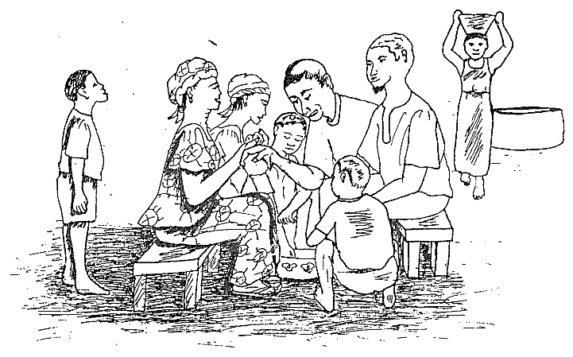

Discuss this definition on decide how you will deal with family members, who live somewhere else and about polygamous households etc.

A plausible definition would be: ***those persons who eat from the same pot belong to a household***

(Duration: 30 minutes)

1. *The household economy tree*

Draw a tree with roots, stem and canopy. The branches represent household expenditures, the roots household income, and the stem represents the flow of resources from income to expenditure

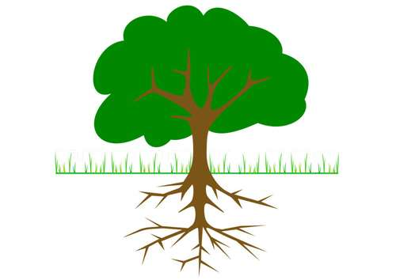

Sale of crops

Salary

Remmittances

agriculture

clothes

medicine

School fees

food

transport

Have blue and red stickers ready and start with the **red**, on which all the different expenditures of a household are written and placed on the branches. Write the various sources of income on the **blue** stickers and place them at the roots.

(Duration: 45 minutes)

**2. Gender roles**

Not everybody in the household have the same roles and responsibilities although all contribute to and enjoy the joint household economy.

Group work on gender roles**:** Three or Five groups are formed with both male and female members. The five different activity areas are distributed between them, so that they at least have two each. Additional lines can be added to all activities. There could be equally shared responsibilities. There could also be shared activities, which are predominantly a male or a female activity area. This can be indicated by numbers of XXXs or otherwise.

|  |  |  |  |  |
| --- | --- | --- | --- | --- |
| **Activity** | **Women** | **Men** | **Girls** | **Boys** |
| **Agriculture production** |  |  |  |  |
| Keeping seed |  |  |  |  |
| Preparing land (ploughing/hoeing) |  |  |  |  |
| Planting |  |  |  |  |
| Weeding |  |  |  |  |
| Harvesting |  |  |  |  |
| Storing |  |  |  |  |
|  |  |  |  |  |
| **Livestock production** |  |  |  |  |
| Keeping chicken |  |  |  |  |
| Keeping shoats |  |  |  |  |
| Keeping cows |  |  |  |  |
| Keeping donkeys |  |  |  |  |
| Keeping horses |  |  |  |  |
| Keeping camels |  |  |  |  |
|  |  |  |  |  |
| **Reproductive activities** |  |  |  |  |
| Fetching firewood |  |  |  |  |
| Fetching water |  |  |  |  |
| Making food |  |  |  |  |
| Washing clothes |  |  |  |  |
| Repairing house |  |  |  |  |
|  |  |  |  |  |
| **Selling** |  |  |  |  |
| Selling crops |  |  |  |  |
| Selling eggs |  |  |  |  |
| Selling small livestock |  |  |  |  |
| Selling big livestock |  |  |  |  |
| Selling eggs |  |  |  |  |
| Selling milk |  |  |  |  |
|  |  |  |  |  |
| **Buying** |  |  |  |  |
| Buys agricultural inputs |  |  |  |  |
| Buys things for the household |  |  |  |  |
| Buys food |  |  |  |  |
| Pays for medicine |  |  |  |  |
| Pays for school expenses |  |  |  |  |
| Saves |  |  |  |  |
| Takes loans |  |  |  |  |
| Repays loans |  |  |  |  |
|  |  |  |  |  |

After discussions in the groups and filling their parts each group makes a presentation and explain their findings.

The overall picture will be that everybody in the household contribute to the household economy. And since we view the household economy as a tree, with common expenses and common income, the household members are like elements of a family business. Like any other business it has to be managed in the most economical way. Therefore, cooperation between the two gender is vitally important. They have to function as a team.

They can be viewed as the core management team of an enterprise called the ***‘family farm’***. This is the basic economic entity for smallholder farmers’ activity. Its economy is identical with the household economy. It includes both reproductive and productive activities. Everything is based on family labour.

(Duration 90 minutes)

**3. Seasonal *income and expenditure of the household***

Draw a line on a flip chart and divide it into twelve parts and write the months

|  |  |  |  |  |  |  |  |  |  |  |  |
| --- | --- | --- | --- | --- | --- | --- | --- | --- | --- | --- | --- |
| Sep | Oct | Nov | Dec | Jan | Feb | Mar | Apr | May | Jun | Jul | Aug |

Then draw the flow of HH income and expenditure month by month over the whole year. At the orange line expenditure and income are equal, below the expenditure are more in the income, while the income is more than the monthly expenditure above the orange line.

|  |  |  |  |  |  |  |  |  |  |  |  |
| --- | --- | --- | --- | --- | --- | --- | --- | --- | --- | --- | --- |
|  |  |  |  |  |  |  |  |  |  |  |  |
|  |  |  |  |  |  |  |  |  |  |  |  |
|  |  |  |  |  |  |  |  |  |  |  |  |
| Sep | Oct | Nov | Dec | Jan | Feb | Mar | Apr | May | Jun | Jul | Aug |
|  |  |  |  |  |  |  |  |  |  |  |  |
|  |  |  |  |  |  |  |  |  |  |  |  |

Discuss briefly what it means when the graph is above the line (blue) and below the line (red). How to deal with months with negative cash flow (e.g. savings, go hungry, take loans)?

*This exercise may actually function better as group work, which will take the double time, but give better discussions and more participation.*

(Duration: 45 minutes)

**Total duration of Session 4 is 3½ hours**

**Session 5: Seasonal calendar, Cash Flow and Savings**

The aim is to understand how cash flow problems in the household economy occur and can be mitigated

**1. The seasonal calendar of agricultural income and expenses**

The participants are forming groups of 3-4 and do group work on seasonal calendar (introduction 10 minutes, group work 30 minutes, feedback 30 minutes).

*Task:* Make a seasonal calendar for your three main market crops based on their combined costs (inputs, labour etc.) and income (sales). The income is above the orange line, cost below

|  |  |  |  |  |  |  |  |  |  |  |  |
| --- | --- | --- | --- | --- | --- | --- | --- | --- | --- | --- | --- |
|  |  |  |  |  |  |  |  |  |  |  |  |
|  |  |  |  |  |  |  |  |  |  |  |  |
|  |  |  |  |  |  |  |  |  |  |  |  |
| Sep | Oct | Nov | Dec | Jan | Feb | Mar | Apr | May | Jun | Jul | Aug |
|  |  |  |  |  |  |  |  |  |  |  |  |
|  |  |  |  |  |  |  |  |  |  |  |  |

*Preparing land Planting Weeding H a r v e s t Sale*

(Duration: 45 minutes)

Compare the household economy flow with that of the seasonal calendar for the main crops and discuss:

1. how you can secure that you have the money you need for planting, weeding/spraying and harvesting
2. how you can keep the money from the harvest to when you need it
3. how you can plan your agriculture activities better
4. how you can organize your household economy better

(Duration: 30 minutes)

**3. Stress and shocks**

The above exercise is based on ‘normal’ years and conditions of the household and agriculture. But there are often events that upset normality. The trainees are split in two groups.

Group A discusses these two questions:

* Make a list of events in the household that can upset the normal flow of funds, e.g. sudden illness
* What measure can you take to address such events - at household level and at community level?

Group B discusses these two questions:

* Make a list of events in the environment, district, country that can upset the normal flow of funds, e.g. drought
* What measure can you take to address such events - at household level and at community level?

The two groups make presentations for the plenary, which discusses the findings.

(Duration: 30 minutes)

**4 Savings**

The facilitator initiates a plenary discussion about different savings methods practiced by the members. The household economy and agricultural seasonal calendars are again presented. The trainees are asked how savings could be used to even out the cash flow an. The facilitator will guide the discussion to the question of savings in groups versus keeping money at home.

(Duration: 15 minutes)

What is a VSLA?

A person has beforehand been invited to come and tell the group how a VSLA works and what she has gained from being a member. The trainees will interact freely with the guest and ask questions.

 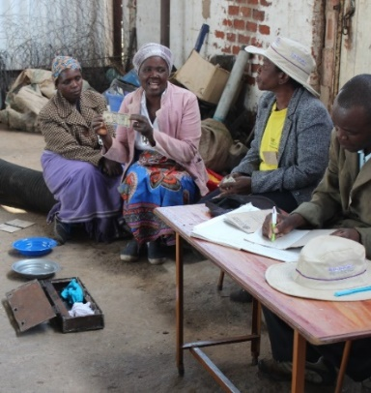

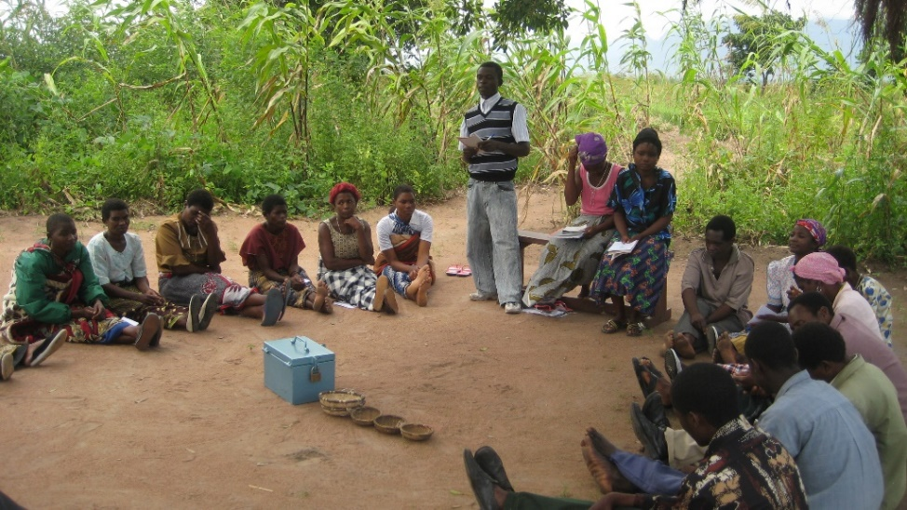 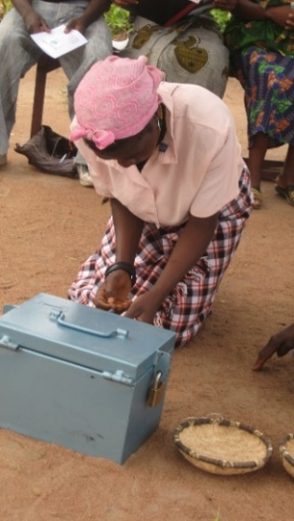

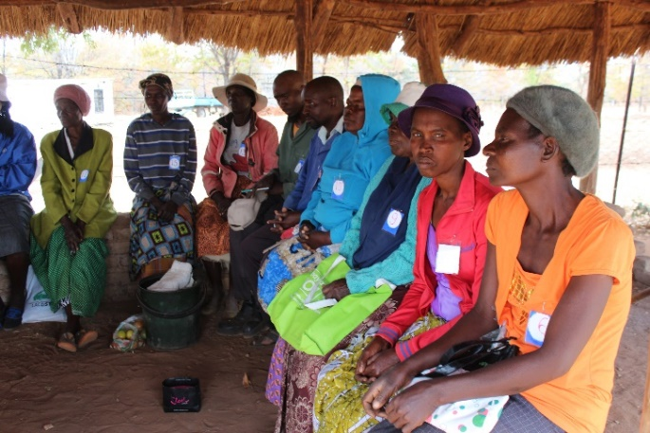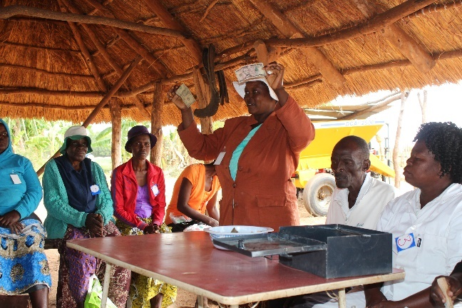

To conclude the section the facilitator will summarise the content of the information meeting.

The FMS group will discuss if they should form a VSLA amongst themselves. In that case a separate meeting is agreed for forming the group with the assistance of a VSLA facilitator.

(Duration: 1 to 1 ½ hours)

**Total duration of Session 5 is 3½-4 hours**

**Session 6: Numeracy**

The aim is to be able to convert different measures and weights into metric units and compare them

**1. Weighing – practical exercise**

The farmers have been asked to bring examples on various types of contains or packaging, which are used as unit, when crops are being sold/bought: bags, buckets, tins, baskets etc. together with different quantities of grains, vegetables, beans etc.

The facilitators have brought (either borrowed or project owned) weighing scale to the classroom. They have brought at least two different kinds of scales: one which can weigh bags of around 50 kg, one which can weigh grams (if this is an electronic scale, bring battery and solar panel and show how this works).

 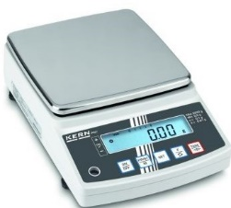 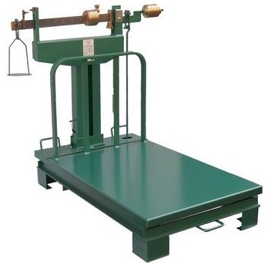

The different weighing scales are demonstrated by the facilitators (15 minutes) and then tried by the students/farmers in the group. If there are three different scales, the groups will try them turn-wise

(Duration: 10 minutes each).

The farmers are now asked to show and explain about the various containers etc. brought

The different crops brought are placed in the containers normally used for that specific crop: tomatoes in a bucket or basket, grains in a bag, beans in a tin. Even heaps of various types are demonstrated.

(Duration: 60 minutes)

The students will now turn-wise (in groups of 3 or 4) weigh the units on the scales and note the metric readings on the scales. Afterwards, when all groups are finished, they will tell their results. These will be compared. And if there are differences, this will be discussed and even – tested by the facilitators in front of the class.

(Duration: 1 hour)

**2. Numeracy training**

The facilitators have beforehand prepared 2-3 numeracy questions related to weighing and weight/volume units. The following are examples – using USD. But the national currency has to be used as well as the locally used units.

a) First the plenary is asked: which price on groundnuts is the highest:

**A. A bag of 50 kg sold at 40 USD - or B. a cup with 400 grams sold at 50 cent?**

After receiving different answers, the crowd is asked to make a vote. The vote will typically be split. The correct answer B = 1,25 USD/kg - A = 0,8 USD/kg

The trainees are split into pairs, who all do the following exercises. Afterwards the class is asked for their individual answers. The correct answers are revealed.

|  |  |  |  |  |  |  |  |
| --- | --- | --- | --- | --- | --- | --- | --- |
| **b) Which is the biggest amount of groundnuts?** | | | |  |  | **ANSWERS** |  |
| 500 g | A | 0,5 | kg |  | A | Third biggest |  |
| 0,4 kg | B | 0,4 | kg |  | B | Smallest |  |
| 1 tonne | C | 1000 | kg |  | C | Biggest |  |
| 1 bag of 50 kg | D | 50 | kg |  | D | Next biggest |  |
|  |  |  |  |  |  |  |  |
| **c) Water melons weigh 1,5 kg each** | | |  |  |  |  |  |
| How much does 3 water melons weigh? | 1 |  |  |  | 1 | 4,5 | kg |
| 20 water melons? | 2 |  |  |  | 2 | 30 | kg |
| 120 water melons ? | 3 |  |  |  | 3 | 180 | kg |
|  |  |  |  |  |  |  |  |
| **d) Which price is the highest per kg of tomatoes?** | | | |  |  |  |  |
| A Price per bucket | 20 | USD | A 20 ltr bucket with tomatoes - weighing 11 kg |  | A | 1,82 | USD/kg |
| B Price per tonne | 1750 | USD |  |  | B | 1,75 | USD/kg |
| C Price per heap | 1 | USD | 5 tomatoes weighing 550 gramme |  | C | 1,82 | USD/kg |
| D Price per plastic bag | 2 | USD | weighing 1kg |  | **D** | **2,00** | **USD/kg** |

(Duration: 30 minutes)

**Total duration of Session 6 is 3 hours**

**Session 7: Market, price and payment terms**

The aim is to understand that in the market there a variety of different kinds of prices and payments terms

1. **Define and describe ‘market’**

Brainstorming and plenary discussion. Put stickers on a flip chart.

*Possible definition:**The market is the place where the exchange of goods and services takes place. The market is made up of sellers, buyers, products and prices.*

(Duration: 30 minutes brainstorming)

1. **Define and describe a price and what influences it**

Prices are dependent on:

* Seasonal fluctuations
* Quantity
* Quality
* Packaging
* More ..

There are different ways a producer can be paid. To most well-known methods are:

* Cash
* Cheque
* Invoice
* Warehouse receipt
* More …

After brainstorming and discussion the facilitator will ask the trainees about what external factors – stress and shocks - can upset the functioning of the market and thus influence prices? (e.g. hyper-inflation, world market slumps)

(Duration: 45 minutes brainstorming and discussion)

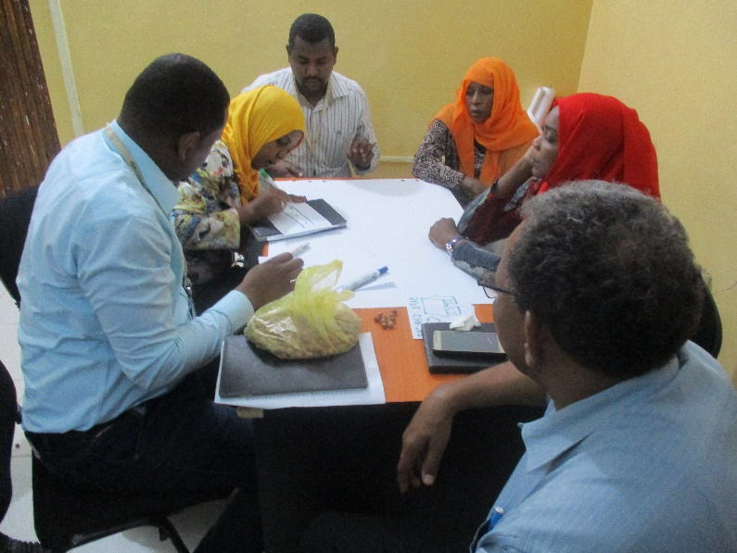

**3. Exercise on price and payment terms**

*The participants will select one of the four scenarios below and develop realistic price examples based on their own experiences*

This is group work, where each group chooses one of the following examples. Calculations must be made in detail and presented in plenary for discussion.

1. *Selling to a wholesaler in instead of a local vendor*

*Choose a community you know well and make the calculation of how much a farmer can gain with selling directly to the wholesaler. Must remember to calculate the extra cost, transport etc.*

1. *Storing crop at home instead of selling at once*

*Choose a crop, which can be stored for a long time and calculate the difference in selling immediately after harvest and selling after a number of months. Must remember the cost of storage: container, house, post- harvest loss etc.*

1. *Selling to a wholesaler and being paid by cheque instead of selling to a vendor and be paid in cash*

*This is similar to a) except that the farmer is not paid at delivery, but after some time and by cheque. Remember to deduct the cost of transport, trips to town, bank charges etc.*

1. *Seasonal prices of graded and ungraded commodity*

*Compare the prices of a seasonal crop of graded and ungraded commodity. Think through which strategy to adopt in order to optimize profit.*

Handout: some examples developed in previous FMS training courses for inspiration (taken from the Master notes.

(duration of this exercise is 2 hours)

**Total duration of Session 7 is 3 hours**

**Session 8: Value Addition and Value Reduction**

The aim is to understand how value can be added to products before selling them. But value can also be reduced before selling by poor handling

**a) Value addition**

The trainees are asked to give examples of value addition from their own experience. To prepare for this session they may also be asked to bring own examples of value addition.

The trainees will probably mention ***grading, packaging*** *and* ***processing*** – maybe also ***weighing*** *and* ***washing***

**1. Grading**

The facilitator asks the participants to give examples of grading and what grading means to pricing.

Exercise: four groups are formed and each group is given a sizable bunch of carrots, potatoes, tomatoes and beans respectively. They are asked to grade based on own criteria. Afterwards each group is asked to explain their criteria and what they expect in terms of price differentails of the various grades

(Duration: 60 minutes)

To sum up the facilitator explains that grading is generally done according to qualities such as size, degree of ripeness, and even colour. The importance of grading can never be over-emphasized as it reduces handling losses during transportation and improves quality thereby fetching higher price to the grower. In addition, grading improves packaging and brings an overall improvement in marketing system. It should always be noted that grading ought to be responsive to the specification that the market demands.

(Duration: 10 minutes)

**2. Packaging**

Packaging of crop produce take different forms. Generally, packaging makes the product become more appealing to buyers and this results in price increases. The facilitator asks the trainees the following questions, which are answered in plenary:

1. What is packaging?
2. What is the importance of packaging in marketing?

The trainees are split in groups and will chose one crop about which they have experience with the value of packaging. They will:

* discuss and illustrate ways of how this crop can be packaged for marketing
* identify different materials which can be used for packaging;
* discuss challenges in packaging and grading

Each group will make a presentation on packaging. It can be illustrated with drawings.

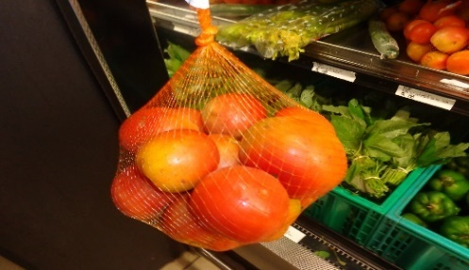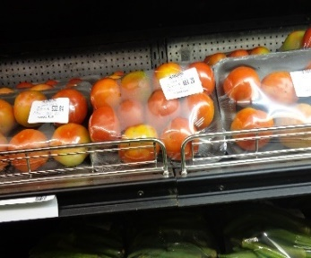

Graded & Packaged tomato in a super market in Malawi

(Duration 45 minutes)

**3. Processing**

Other methods are semi- or full processing

Processing can be:

Semi-processing: An example is to shell groundnuts. The shelled groundnuts are paid better than unshelled groundnuts. The shelled groundnuts can be graded, which will add additionally to the price. But it is important to stress that the price information and the grading specifications must be known from the market beforehand. Drying of *bamia* is another popular method of doing semi-processing in Sudan. Semi-processing is relatively simple to do and can be done by all farmers.

Full processing: To make graded peanuts into peanut butter is very popular amongst some producers. A manual machine is needed, so are jars and labels, and the processing must take place in very clean premises. It is important to research the market thoroughly before starting such processing, as ***there may be a competition with factory made peanut butter, which can be difficult to beat!***

Sun drying of fruits and vegetables and centrifuging of honey are also wide-spread methods to do farm-based processing, but again: market analysis is important before starting the process.

The same groups continue and discuss examples of processing of crops that they know. They have to list advantages and disadvantages of each example.

(Duration: 30 minutes)

**4. Value reduction by poor pre-market management**

In some cases, a crop loses value from the time of harvest to it reaches at the market. This process is important to know, so that the farmer can try to reduce this loss of value.

Farmers may know something about post-harvest management. Extension staff often offer training and advice on this. Sometimes, farmers invest in storage facilities in order to protect a crop after harvest.

But pre-market market management is slightly different, because it takes it starting point at the delivery point, where the buyer takes over a crop and pays for it. The buyer will look critically at the ripening stage of fruits, at damages on perishable crops, at amount of soil on potatoes etc.

A wholesaler in Harare, who buys bananas from smallholder farmers described the damage on the crop from harvesting to delivery. In his analysis the freshly harvested banana goes through nine sets of hands – or other kinds of handling – before reaching his clod store in Harare. Every touch can produce a brown spot on the banana and subsequently lower its price. How the crop is transported is one example of possible damage and value reduction. This includes shifting from one means of transport to the next. He wished, he said, that the farmers knew much more about this.

**Exercise: How to avoid value reduction through poor handling from farm to end-buyer.**

Three or four groups are formed. They will choose a crop they know and describe its handling from the time of harvesting, from storing to transport and delivery to end-buyer.

The various actions are listed – and in connection with each of them means are suggested to potential crop loss of value.

Each group illustrates the discussion on a flip chart and explain to the class.

(Duration 45 minutes)

**Total duration of Session 8 is 3 hours and 10 minutes**

**Session 9: Value chain mapping**

The aim is to visualize a simple value chain and understand its importance

The facilitator explains what a value chain is by using the example below (Duration: 30 minutes)

**1. The value chain map**

***Example of the value chain for tomatoes***

*There are around 7,500 different varieties of tomato, and tomatoes are being used for many different purposes. The value chain for tomatoes from producer to consumer would thus offer a number of different paths to take. Many smallholders would probably only know the direct path to a consumer on the local market (1) or to a middleman (2). But it is still important to note quantities demanded, price and consumer preferences in these two chains – as well as in (3) and (4).*

**Consumer A**

**Input supplierman**

***1***

**Consumer B**

**Middleman**

**Transporter**

**Restaurant**

**Consumer C**

***2***

**Tomato-producer**

**Retailer**

**Consumer D**

**Wholesaler**

***3***

**Processing company – e.g. tomato tins, ketchup, paste**

*4*

**Consumer E**

**Retailer**

**Wholesaler**

**Wholesaler**

*Chain 3 has more links with more actors involved, while chain 4 is even more complex, because it involves processing. The input supplier is not a chain actor as such, but s/he is important as a key informant and a possible supplier – could even become a trainer. The transporter is also not a chain actor, but s/he is important for the chain. This diagram shows four trips of the tomato value chain.*

***Exercise:*** Organise the participants into small groups of three and ask each group to select a product that they are familiar with. Ask them to answer the following questions:

* Who is the final consumer?
* What are the different ways to market their product?
* Where does value addition take place and how?
* Which service and input providers are necessary for the chain to work?
* What are the constraints they might experience when selling their product?

The flip charts with each group’s value chains will be presented to the other participants

(Duration: 2 hours)

**2. The Input supplier and the final customer**

Farmers typically focus on the first links in the value chain. But it is important to understand the full value chain in order to know exactly what the market wants. In cases where the products are exported – birds’ eye chilli - or processed – cotton, it can be difficult for the farmers to know exactly who the end-consumer is, and what the end-consumer wants. But even some knowledge is better than no knowledge. Malawian farmers produce pigeon peas, which is exported to India. They do not know what the Indian consumer prefers, how the food, they make is prepared. But in each major town in Malawi there are Indian shops and restaurants.

An FMS member in Zimbabwe, who produced cabbage, found out that the customers would typically buy a whole cabbage, but only use half of it for a meal. A big cabbage would not fit into the refrigerator. The other half would be kept for later, but often had to be thrown out as it grew bad. She then cut her cabbages in half and wrapped the half cabbage with two carrots in cello-foil and sold this as one unit to a green grocer, thereby doubling the price of her product.

Group work:

1. Each group will choose three products they produce and try to identify the end-user – the final consumer in the value chain. To each product, they will write how they will find out about the end-user’s preferences and suggest ways how the farmer could satisfy the needs of the end-customer.

2. They will then as a second task list the important inputs suppliers, transporters and other, which are necessary to bring the product from the farm to the end-consumer.

Each group will present their findings for the class.

(duration: 60 minutes)

**Total duration of Session 9 is 3 hours**

.

**Session 10: Communication skills**

The aim: is to develop good communication skills to be used in dealing with value chain actors

**1. Listening skills**

1. Difference between hearing and listening

Exercise: role play with three scenes

1. Two people meet. One of them starts to talk and gets exited and involved in what s/he is talking about. The other person tries several times to speak, ask a question or make a suggestion, but the first person keeps on speaking, and the other becomes silent and gives up trying (The pair should decide a topic beforehand)
2. Two people meet, and both start telling something. But they each have a different topic. Neither is listening to the other, and both are talking at the same time
3. Two people meet, great each other and start a real dialog. Each one asks questions about the other’s answer and they share their own news and opinions (A common topic should be agreed beforehand)

1. Problems of listening

Groups of five-six people are formed. Each person in the group will choose a subject and give a talk for 2 minutes. (subjects could be - ‘are men and women equal’, ‘the importance of nation al unity’, ‘food and lodging at the workshop’ etc.). While one person speaks the rest of the group listens in silence. No interruption and questions are allowed. When all have spoken, the group will discuss the experience and answer the question: What helped you listen well and what made it more difficult to listen?

All the answers are written on a flipchart in two columns with the headings ‘helpful’ and ‘difficult’.

The flipcharts are presented to the participants and discussed. The facilitator is writing the most important statements on a chart and makes a summary, which will say that it is equally important to be a good listener as being a speaker, who can make other people listen well.

This exercise has been successful if participants have become more aware of how well (or bad) they are themselves as listeners and what they can do to improve their listening skills

(Duration: 1 hour and 20 minutes)

**2. Interviewing**

1. Exercise: Triadic interviews
2. First, the participants are divided in groups of three (triads)
3. Second. In each group one person (A) will interview another person (B), while the third is an ‘observer’, who will leave them alone and not listen to their talk. The topic of the interview is the daily activities of the interviewee (“please tell about your activities of an ordinary day!”)
4. Third. After five minutes interviewing, the observer will return and interview A to learn, what s/he learned from (B). (B) remains silent during this part, but will afterwards add his/her comments to correct misunderstandings and add omissions. The roles will be shifted until all three have tried all the three different roles.

In a plenary session the participants will discuss their experience. Following questions can lead the discussion:

* *What questions made the interview successful?*
* *Why did the interviewer omit or distort information, when trying to recall it for the observer?*

(Duration: 1 hour)

1. Good and bad interviewing

A person is chosen (maybe a facilitator or strong member of the group) to conduct a ‘bad interview’, which could e.g. be a topic related a market price.

1. *Bad interviewing*

Ingredients in a ‘bad’ interview may be:

* Not explain the purpose of the interview
* Constantly interrupting the speaker
* Writing down answers while ignoring the interviewee
* Disinterest (use body language)
* Appearing in a hurry
* Passing judgement on what the interviewee says
* Refusing to restate a question when asked to

1. *Good interviewing*

Ingredients in a ‘good’ interview may be:

* Making the purpose of the interview clear from the beginning
* Establishing a positive atmosphere
* Acting flexibly by restating or clarifying questions if asked to
* Showing interest in whatever is said without passing judgement on what the interviewee says
* Being a good listener and observer – e.g. using body language like eye-contact, smiling, nodding
* Finding time for a brief conversation with the interviewee at the end of the interview

After the two examples the plenary is asked to list the mistakes done by the interviewers and the differences between the two examples. A list of ‘bad’ and ‘good’ interviewing can be made in two columns on a flip chart.

(Duration: 45 minutes)

**3. Non-verbal communication**

Ask participants to form four or five groups. Each of the groups will pick pieces of paper from a basket or bag. The paper will have written on it an emotion that the group will act out, without talking. Each group should assign one person to act out or ‘mime’ the emotion. S/he may use facial expression, movements, body language, exaggerated if necessary but no words or sounds. Other participants try to guess the emotion or feeling.

After guessing the emotions, ask the group whether it was easy to communicate messages without words.

Aske them – and write on the flip chart – some points about non-verbal communication. First ask about issues dealing with voice e.g.:

* Choice of words
* Tone
* Speed

Then ask about issues dealing with body language e.g.:

* Smiles
* Raised eye brows
* Head movements
* Physical distance and position
* eye contact

(Duration 25 minutes)

**Total duration of Session 10 is 3½ hours**

**Session 11: Negotiation and Contracting**

The aim: is to develop good negotiation skills and understand various forms of contracts between buyer and seller

**1. Negotiation**

In this role play a buyer is meeting a potential seller, who represents a group of farmers. They have already met before, where the farmers got some basic price information and other information, which has made the group interested. So, they have planned to meet again to strike a deal with the buyer. One person is selected to be the buyer (could be the facilitator!).

The FMS members divide themselves in three groups and each of them prepare to send a delegation of two to make the deal. Their aim is to get a better price and better payment terms. They will prepare the meeting in each group and the role play consist of a scene, where the buyer sits in the office and the farmer representatives knock on the door.

During each of the three role plays the other two groups are observers and make notes. But they will not be able to discuss these before all the three role plays have been completed.

(The buyer is getting instructions by the facilitators on his/her role, which is that of a willing, but slightly skeptical buyer in all three cases. The buyer will be instructed **not** to make the final deal, but this is not known by the three groups!)

In the discussion after the role play will be based on comments made by the observers. The facilitator will lead the discussion, and will structure the comments around questions like:

* What was good in the first, the second and third scene?
* What was not good in the first, the second and the third scene?
* l How did you prepare your delegation?
* Did the meeting create closer relationships between the buyer and the seller?
* What would the first group do to make a new meeting better?
* What would the second group do to make a new meeting better?
* What would the third group do to make a new meeting better?

(Duration: 60 minutes)

**2. Contracting – contract farming**

Explain how a contract looks like. The example is a contract between a company and farmer to grow green beans. Its main points are written on a flip chart and explained by the facilitator.

*A. The Company agrees:*

To provide high-quality seed

To supply fertilizers and agro-chemicals required for the area of green beans planted by the Farmer.

To advise the Farmer on all technical aspects of growing green beans.

To buy all green beans of acceptable quality

etc

*B. The Farmer agrees:*

To plant the bean seeds supplied by the Company)

To follow all technical recommendations made by the Company

To sell all green beans of acceptable quality grown on the farm to the Company

etc

*C. Payment for green beans and production inputs shall be determined as follows:*

Payment for green beans delivered each month, less the cost of fertilizers and agro-chemicals taken on credit, will be made before the 15th of the following month

etc.

*D. Penalties and Bonuses*

*F. Dispute Settlement*

*G. Signature*

*Grade specifications and Quality Requirements*

(The full text (below) is given to the farmers as a handout)

**HANDOUT**

**A. The Company agrees:**

**(1)** To measure and assess the suitability of the plot proposed by the Farmer for planting green beans.

**(2)** To provide high-quality seed to the Farmer in good time for planting, in the quantity required for planting the accepted area of land.

**(3)** To supply on cash payment (or on credit once the Farmer has qualified as an established and reliable contract grower) the type and quantity of fertilizers and agro-chemicals required for the area of green beans planted by the Farmer.

**(4)** To advise the Farmer on all technical aspects of growing green beans.

**(5)** To buy all green beans of acceptable quality grown by the Farmer, for a price announced at the start of each growing season. The quality requirements will be as described below.

**(6)** To pay the Farmer his/her dues as described in para 4 below.

**B. The Farmer agrees:**

**(1)** To use the part of his/her farm that has been surveyed and approved by the Company, for the purpose of growing green beans for the duration of this agreement.

**(2)** To plant the bean seeds supplied by the Company on this land, on the dates and following the procedures advised by the Company.

**(3)** To follow all technical recommendations made by the Company with regard to planting, irrigating, weeding, fertilizing, controlling pests and diseases, picking, sorting and packing green beans.

**(4)** To sell all green beans of acceptable quality grown on the farm to the Company, for the price and following the procedure outlined in para 4 below.

**(5)** To become a member of xx Farmers' Group, and to contribute to the maintenance of common facilities for irrigation, input distribution, sorting, packing etc as agreed by the group.

**C. Payment for green beans and production inputs shall be determined as follows:**

**(1)** The base price at which each grade of green beans will be bought will be announced by the Company at least one month before the start of each planting season.

**(2)** The prices at which fertilizers and agro-chemicals will be sold will be announced at the same time, but may fluctuate during the year in line with exchange rate fluctuations.

**(3)** Payment for green beans delivered each month, less the cost of fertilizers and agro-chemicals taken on credit, will be made before the 15th of the following month.

**D. Penalties and Bonuses:**

**(1)** If the Farmer delivers green beans which do not meet the agreed quality standards, the Company will reject them. The Farmer may re-submit them after sorting, but the Company is under no obligation to accept beans which do not meet the agreed quality standards.

**(2)** If the Farmer fails to follow the procedures detailed in this agreement, he/she will be warned verbally and in writing. After three written warnings the Company has the right to terminate the agreement.

**(3)** If the Company fails to fulfil its commitments as detailed in para 2 above, the Farmer has the right to claim compensation to the value of the services foregone or to the value of the crop lost, at rates agreed between the Company and the Farmers' Group.

**(4)** If the Farmer delivers green beans which exceed the required quality standards or the expected level of production, he/she shall be eligible for a bonus at a level agreed between the Company and the Farmers' Group.

**E. Duration of the Agreement:**

**(1)** This agreement will last for one growing season from the date of signing to the end of the economic harvest of the green bean crop.

**(2)** If both parties are satisfied with the outcome of the agreement it may be renewed for a further season, but there is no obligation on either party to renew the agreement.

**F. Dispute Settlement:**

**(1)** Any dispute arising as result of this agreement will be settled wherever possible by discussion between the Company, the Farmers' Group and the Farmer.

**(2)** Any dispute which cannot be settled by this process will be referred to an independent arbiter acceptable to all the parties involved.

**G**. **Signature:**

I have read and understood the contents of this agreement and I sign it of my own free will.

----------------------------------------------- (Farmer)

----------------------------------------------- (Company)

----------------------------------------------- (Witness)

----------------------------------------------- (Date)

**Grade specifications:**

**(1)** Grade 1 beans (extra fine) are from 6.5 - 9.5 cm in length.

**(2)** Grade 2 beans (fine) are from 9.5 - 11.0 cm in length.

**(3)** No other sizes will be accepted

**Quality Requirements: acceptable beans must be:-**

**(1)**free from pests, wounds, scars, bruises;

**(2)** free from mud, dust or other debris;

**(3)** not broken or damaged in any manner;

**(4)** not bent;

**(5)** picked with the remains of the calyx intact;

**(6)** fresh and not pre-wilted by sun-burn or other sources of heat;

**(7)** naturally green, not tainted by disease, smoke etc.

Three groups are formed, and they get copies of the full contract form. They will make two lists: 1. Advantages and 2. Disadvantages of agreeing on this contract with the company.

Afterwards, the groups will present their lists for the plenary.

In a plenary discussion, the farmers will give their judgment if they would be ready to enter into such a contract or not.

(Duration: 1 hour 30 minutes)

**‘Open’ contract**

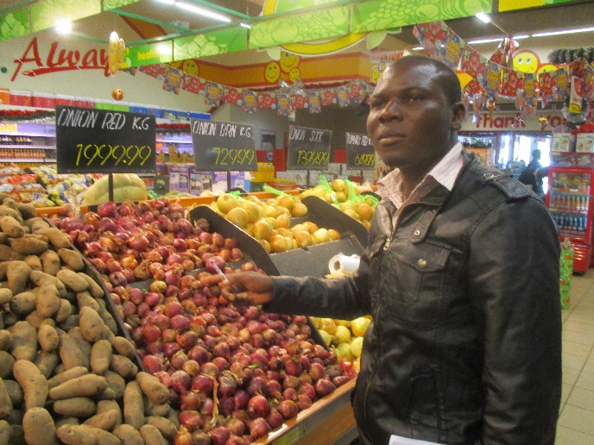

*The ‘fresh product’ purchase manager of Shoprite supermarket in Mzuzu, Malawi, entered into an open contract with an FMS group for weekly delivery of vegetables*

The **‘open contract’** (which is basically just a verbal contract) is explained in a role play, where one of the groups from the negotiation role play show how the farmers agree with the buyer on a verbal contract.

The buyer suggests

* Time of delivery
* Quantity
* Payment terms

The farmers agree on time and quantity, but they negotiate the payment terms. They prefer cash, but the buyer starts by offering payment by check by the end of every month. They finally agree and shake hands.

The audience is asked to comment on the role play, listing its advantages and disadvantages and finally comparing and contrasting the ‘open contract’ with the written contract method.

(Duration 60 minutes)

**Total duration of Session 11 is 3½ hours**

**Session 12: First Trip – to the local market[12]**

The first visit to the market has the aim of giving the FMS-trainees a first practical chance to use some of the skills they have learned, including interviewing techniques.

In past trainings we have seen how this first visit becomes an eye-opener to many trainees. They feel comfortable with the local market, because they know it. Probably they know many of the traders and businesses already. But when they start interviewing them about their business, they realise that there are many details they did not know about.

In the FMS evaluation, it is described how this first market visit triggers a ‘wow’ moment – or ‘disorienting dilemma’: *‘At this location (that comprises an open informal market, shops, restaurants of various kinds, bars and guest houses), which they have visited many times before, they are taken by surprise when, through systematic interviews, they realize how different the potential buyers are from each other and how they each represent different market opportunities. Some require quality, while others want the cheapest product; some pay cash, while others need credit; some want to build a long-term business relationship, while others want to cheat you’.*

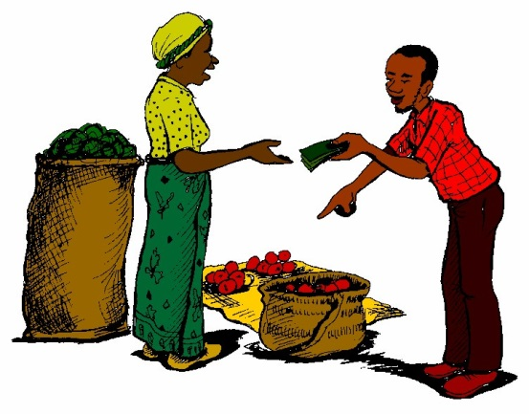

Aim: To give the participants first-hand experience in studying the market, identifying market actors and their roles

Materials: Exercise books

Preparation by the facilitator:

At least a day or two before this session, you will need to locate a market near to where the FMS is being held in order to

1. Make sure that there is enough going on for the participants to learn (there needs to be a good variety of products sold at the market).
2. Make sure that there are enough market actors including potential buyers such as hospitals, retailers, supermarkets, restaurants etc. they can explore.
3. Find out the best day and time to visit the market.
4. Plan the details of the visit.
5. Organise transport (if required) to the potential buyer

**Exercise 1: Preparing for the visit to the market**

Preparation: Write the following on the board: *Visit to the market: Key questions*

Then let the participants suggest the questions by brainstorming. The facilitator may suggest additions or slight modifications. The list below is a list of possible questions. But it is important that participants understand the questions and agree on them in advance, so these additional questions should only be suggested by the facilitator, if the response by participants is poor.

*Examples of such extra questions:*

1. *How does the product get to market?*
2. *How much of the product can the market handle?*
3. *When does the market want the product? All year long? Only in certain seasons?*
4. *What kind of packaging is used, if any?*
5. *What is the physical condition of the product? Does this change? How? Why?*
6. *Who owns the product being sold? The producer? Someone else? How does this work?*
7. *Who buys the product?*
8. *How are products paid for?*
9. *How is the money handled?*
10. *What happens to products that are not sold?*

Process:

1. Let the participants form groups of 2 (or 3 if needed). One should be literate.
2. Ask each group to choose 2 products to investigate at the market. Explain that when they get to the market they are to walk about the market to meet and talk to people who are selling and buying and handling the two products they have chosen.
3. Ask each participant to use their log books to remember information, but caution them against writing in the book, when e.g. interviewing a market actor.
4. Make a value chain map of your crops based on Who sells? Who buys? And at what prices and specifications?

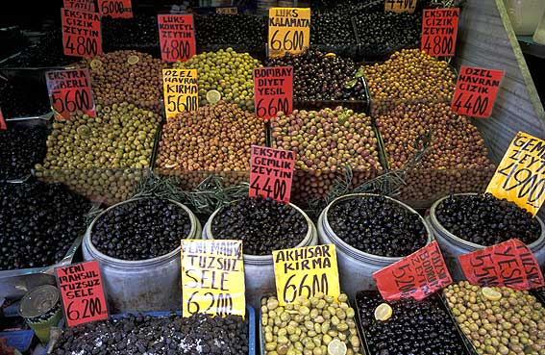

**Discussion: after the market visit**

Process:

1. Ask each group presents their value chain maps and share what they learned.
2. Use the same list of questions used for the visit as a guide to this discussion.
3. Encourage discussion.
4. Briefly ask the participants to summarise what was learned.
5. Choose the next product to discuss. Repeat the process until all the products have been discussed.

For those who did not succeed to make value chain map

1. Ask them what they have found out, e.g. on prices, packaging, services
2. Ask the participants to summarise what was learned from these findings

(Duration: This exercise is best done over two half days or a full day: It requires one hour joint preparation + half a day on a market + 1hour group work to prepare their presentation + 2 hours discussion)

**Session 13: Preferred market crops/products**

**1. Listing the crops/products**

The aim will be to identify a shortlist of marketable crops/products

Every crop or agricultural product, which is sold, has its own specific value chain. There is nothing called the ‘agricultural value chain’. The end-use of one agricultural crop is different from another. Papaya and banana are both used for immediate consumption, but also have other very different uses. Some papayas end in juice shops in Sudan, Ethiopia or Eritrea, where papaya juice is very popular. But other papayas – produced in the highlands of DR Congo and Uganda are processed into papain – an important enzyme used in the food industry worldwide. The banana is multi-purpose plant with thousand varieties – all having their separate value chains. The two plants only find themselves together on the farmers field. When they are sold they end up in different parts of the world being used for different purposes.

All farmers know what they are good at producing. They also know something about the immediate markets and its demand for their products. But they do not know all the details of what happened to their product later down its value chain. This has to be researched. And that is the key activity of the Farmer Market School. But all crops cannot be researched at the same time. Actually, the FMS training recommends that the FMS students choose only one crop to start with.

Therefore, the preferred crops or products, have to be identified and agreed by the FMS class. And one of them have to be agreed as the first one to research. It is important that this crop is known to all of them, and that it also is one that farmers pin some hopes to in terms of market demand. It is important to stress that livestock products, egg, meat, milk, honey and fruit tree crops like mango, avocado can be among the preferred ‘crops’. Even non-agricultural products such as basketry are also can also be on the list.

The selection process of this crop/product is the following:

In the previous meeting FMS students are asked to hold a meeting with the farmer group they come from. They are tasked with identifying three important crops that they want to do market research on e.g. tomato, pigeon pea and groundnuts.

In the meeting each student will mention their three preferred crops, which will be listed. The one mentioned most times will be chosen. The list – after every student has mentioned his/her priorities could look like this:

1. Green grams
2. Maize
3. Mangoes
4. Beans
5. Paw paws
6. Pigeon peas
7. Watermelon
8. Kales
9. Tomatoes
10. Local chicken
11. Goats
12. Chickpeas
13. Cassava
14. Sweet potatoes
15. Groundnuts
16. Cow peas
17. Finger millet
18. Sorghum
19. Honey

|  |  |
| --- | --- |
| 1.     Green grams | 2 |
| 2.     Maize | 1 |
| 3.     Mangoes | 4 |
| 4.     Beans | 3 |
| 5.     Paw paws | 1 |
| 6.     Pigeon peas | 10 |
| 7.     Watermelon | 3 |
| 8.     Kales | 1 |
| 9.     Tomatoes | 6 |
| 10.  Local chicken | 7 |
| 11.  Goats | 1 |
| 12.  Chickpeas | 4 |
| 13.  Cassava | 2 |
| 14.  Sweet potatoes | 1 |
| 15.  Groundnuts | 6 |
| 16.  Cow peas | 1 |
| 17.  Finger millet | 2 |
| 18.  Sorghum | 1 |
| 19.  Honey | 4 |
|  | 60 |

Pigeon peas is the clear winner. The choice of the been made.

But there may be a different result with 3, 4 or 5 crops/products have very similar results. Then every student will have one vote in a final poll. The result may be like this:

|  |  |
| --- | --- |
| 1. Pigeon peas | 8 |
| 2. Local chicken | 2 |
| 3. Tomatoes | 5 |
| 4. Groundnuts | 5 |
|  | 20 |

It is important is that the students feel that the chosen crop/product is relevant to them. There have been cases, where the students have chosen two products: pigeon peas and chicken. This meant that the group became sub-divided. This should be avoided for the first market visit, which serves as a learning on how to carry out the research.

(duration 60 minutes)

|  |
| --- |
| **C. Travels along the value chain** |

At this stage the role of the facilitator is changed. The farmers are now in charge of decision making. The FMS trainees will spend time with the organisations they represent and may not meet as a group again, unless they decide to do so. The initiative for the way forward is theirs.

Its FMS Master trainer will keep contact to the trainees by telephone or through a Wats-up. If a joint meeting is requested the FMS master trainers will delegate the organization of the meeting to one or two of the FMS trainees, but he/she will take notes for the final FMS report.

The FMS master trainers will also visit all the individual organisations at least once in this period – just for an update. This will a monitoring visit, where an update is made. These meetings are again documented as part of the FMS report.

**C.1 Second Trip**

This trip will aim at getting a general orientation about the prospects of the products on the list of possible market crops identified earlier, how the value chains look like and who the actors are. Price information at the different levels on the chain will also be collected. The representatives of the group will travel on their own and use their communication skill and information gathering methods.

1. **Preparation of first major value chain trip**

* Selection of persons to undertake the travel
* Make a travel plan
* List the questions to raise and plan how to get the information
* Make a budget for the trip
* Decide when, raise funds and fix other logistics

(Duration: a half day)

1. **Travel along the value chain**

It can be decided in **exceptional cases** that one or two of the FMS master trainers join the trainees/group representatives on this first major trip away from the village, and that it is part-funded by the project. **(This must be discussed and agreed upon beforehand!)**

(Duration: 2 days)

1. **Meeting after the trip**

In this meeting the representatives who have travelled will present their findings and the group will analyse and assess these findings from the trip. This is a very crucial meeting, where it can be expected that the number of marketable crops is being reduced e.g. from 5-7 to only 2-3 crops of market relevance. It will also be decided when a follow up trip will be made and the information collection process continued.

(Duration: a half day)

**C.2 Third Trip**

The third trip: Focus will be on visiting selected value chains and following up in more detail. Contacts should be established with buyers and specifications, technical questions and prices will be discussed. Representatives from the groups will be selected to participate to undertake this trip. The representatives will report to the rest of the groups.

* 1. **Preparation of third value chain trip**

Focus of this trip will be on visiting key actors and making deals with these

* Selection of persons to undertake the travel
* Make a travel plan
* List the questions to raise and plan how to get the information
* Make a budget for the trip
* Decide when, raise funds and fix other logistics

(Duration: a half day)

* 1. **Travel along the value chain**

This time none of the facilitators will join the trip

(Duration: 1-2 days)

* 1. **Meeting after the trip**

In this meeting the representatives who have travelled will again present their findings and the group will analyse and assess these findings from the trip. The value chain maps with prices, name of companies and persons etc.

In this meeting a decision could be made on which value chain to choose for the coming season and which value chain actors to get into business with. The likelihood of this being the time of planting and the beginning of the agricultural season, it is important that the group members make the decisions when to continue the process. It could be immediately, or after the harvest

(Duration: a half day)

**\*\*\*\*\*\*\*\***

**C.3 Fourth trip (- and more trips!)**

This trip (and following trips) will go through the same stages of the previous ones.

1. **Preparation of fourth value chain trip**
2. **Travel along the value chain**
3. **Meeting after fourth trip**

Depending on how the process is unfolding there may be more trips and meetings, telephone calls etc. The FMS members are now fully taking over the process and the facilitators will become observers – may even not take part in all meetings anymore.

|  |
| --- |
| **D. Conclusion, Monitoring & Evaluation** |

**D.1 Follow up meetings**

As mentioned, the FMS Master trainers will visit each of the participating organisatins in the period, when they are doing individual travels along their value chains.

Questions to address are the following (and many more!):

* What action – as an organization - have you already taken during the duration of this FMS regarding your market crops?
* What are you planning in terms of production and marketing in the coming year/season?
* Which issues that have not been part of the FMS would you need to learn more about – examples: negotiation, contract farming?
* More ……

(Duration: 45 minutes+)

**D2. Post-harvest session**

After having sold the first crops harvested after the FMS training, they initial FMS group is meeting to follow up on their final experiences with the whole cycle from knowing what the markets want - to producing for the market for the first time.

The self-monitoring tool is now completed with data from the first harvest after training.

The Master trainers then ask the members to give detailed feedback on their experiences – good and bad. This may include new needs for training and support. The Master trainers will take notes and make photos of the self-monitoring tools. These photos will be part of the facilitators **final FMS report**.

This may also be a meeting where a public presentation of the FMS group’s result is made.

(Duration: a half day)

**D. 3 Celebration of the end of the FMS!**

This event is organized by the Master trainers and the trainees together. Local administrative leaders and key farmer organization leaders are invited. Some may be delivering speeches.

The trainees will make a presentation of the learning from the FMS at a public meeting in the District. This all needs to be prepared in advance.

Then there will be a small celebratory graduation ceremony, where participants are issued with certificates of participation and a T-shirt with the words ‘Farmer Market School’ written on the back.

(Duration: Half day)

**D.4 Report writing**

Another final activity (compulsory) is the production of **an FMS report** by the Master trainers, where all components and sessions, including what has been discussed in plenary sessions, must be documented. There will be two reports to write for the facilitator:

* One after the training sessions
* A final report, which include the training report, but also documentation of the follow-up meetings/communication and the post-harvest meeting as well as the celebration/graduation
* This final report will be sent to initial FMS Master training coordinator and to the involved organisations and the relevant local administration.

**Sample of a certificate**

# http://www.faceofmalawi.com/wp-content/uploads/2014/08/ADRA.jpg

# **Malawi & Denmark**

**CERTIFICATE**

# **of attendance**

### It is hereby certified that

----------------------------------

has participated in a 3 days training workshop on

‘**Facilitation of Farmer Market Schools’**

in Mzuzu from the 23rd to 25th February 2016

Mzuzu, Malawi, 25th February 2016

----------------------- ----------------------

Christian Sørensen Claudio Sandoval

Trainer Country Director

ADRA Denmark ADRA Malawi

## 

**Bibliography and Resource Material**

* **The Farmer Field School Approach – History, Global Assessment and Success** Stories by Arnoud Braun and Deborah Duveskog in Background Paper for the IFAD Rural Poverty Report 2011
* **Farmer Business School Manual PART 1. Pre-season, Part 2 Farm Enterprise: Implementing Guide,** Ministry of Agriculture, Malawi
* **Farmer Business School Training of Farmers Programme, South Asia, Handbook,** FAO Regional Office for Asia and the Pacific, Bangkok 2011
* **Smallholder Farmers and the Market Lessons Learnt from a Pilot Project in Kitui District in Kenya, on the ‘Territorial Approach to Agro-Enterprise Development’.** By Christian Sorensen and Paul Mbuthia, ABD Kenya 2008
* **Pilot project on Farmer Field Schools in Malawi,** Action for Social Change, Various progress reports, ADRA Malawi, 2014-15. The latest of these reports is ‘**Trip report to** ***project groups and Farmer Associations in Mulanje & Machinga***, Christian Sørensen, May 2015)
* **A Territorial based Approach to Agro-Enterprise Development** Strategy Paper: Territorial Approach to Rural Agro-enterprise Development by Mark Lundy, Carlos Felipe Ostertag, María Verónica Gottret, Rupert Best and Shaun Ferris, Rural Agro-enterprise Development Project, CIAT
* **The Farm Business School Training of Farmers Programme South Asia Manual**, FAO and UN Reginal Office for Asia and the Pacifics, Bangkok, 2011.
* This manual is easy to read and use. It contains training sessions on relevant subjects such as:

*Group marketing, Group buying and saving, Understanding contract farming and contract appraisal, Assessing and managing business risks, Value addition*

<http://www.fao.org/docrep/014/i2136e/i2136e00.pdf>

* **Participatory Market Chain Analysis for Smallholder Producers,** by CIAT and CRS 2007/2008.

This manual is based on long experience of CIAT to promote participatory agro-enterprise development. It focuses a lot and in detail on market research, the dynamic nature of markets and the selection of the most viable agro-enterprises and market chains from a list of options.

<http://www.crs.org/sites/default/files/tools-research/participatory-market-chain-analysis-for-smallholder-producers.pdf>

* **Online Learning - Agricultural Numeracy for Food Security and Nutrition**

This is an interactive online learning programme on agricultural numeracy, which is the foundation for exact farm recording and for crop forcasting

<http://www.agritechtalk.org/Uno%20How%20Introduction.html>

* **VSL Associates** is providing programme guides and manuals for facilitators and VSLA trainers in many different languages. Can be downloaded from this link: <http://www.vsla.net/programmetool/programmeguides>
* **Farming as a Family Business – Training Manual**, Zimbabwe Agricultural Competitiveness Program/USAID, 2012

This is a relevant manual dealing with subjects such as:

*Household economy, Farm recording, Farm budgeting, Finance, Contract farming*

<http://pdf.usaid.gov/pdf_docs/PA00JRZQ.pdf>

* **Gender, the Economy and Budgeting** by Zimbabwe Centres of Excellence for gender mainstreaming in Local Government
* This training manual focuses on gender and the economy on budgeting and economic management
* <http://www1.uneca.org/Portals/ngm/Documents/Gender%20Mainstreaming/Zimbabwe-GM-Module7.pdf>
* **Financial Literacy for Smallholder Farmers**, GiZ, Kampala, March 2016

This manual is a very use friendly introduction to all aspects of finance, money management, loans etc.

<http://www.simplifymoney.co.ug/for-our-partners/resources/training-package/farmers-manual.html>

* **Farmer Market Schools in Zimbabwe and Malawi – Consolidation of knowledge based on four evaluations and quantitative studies**, by Esbern Friis-Hansen, September 2018 (for ADRA)
* **Advice Manual for the Organisation of Collective Marketing Activities** by Small-Scale Farmers, P. Robbins, F. Bikande, S. Ferris, R. Hidges, U. Kleih, G. Okoboi and T. Wandschneider, The University of Greenwich for Catholic Relief Services, 2004.
* <https://www.crs.org/sites/default/files/tools-research/organisation-of-collective-marketing-activities-by-small-scale-farmers.pdf>
* **Trainers’ Guide for Farmer Field School Facilitators – Draft facilitator’s Guide Developed at the FFS Master Trainers’ Course conducted at Lissadzi, Mzuzu and Thuchira Residential Training centres within the KULIMA programme, December-May 2018.** FAO, Lilongwe Malawi, May 2018
* **Pastoralist Field School – Training of Facilitators Manual -** FAO, 2013

<http://www.fao.org/3/a-bl492e.pdf>

* **Introduction of the SHEP approach**, JICA February 2015

The SHEP approach has a number of similarities with FMS – especially in relationship to the importance of smallholder farmers’ awareness and behaviour changes – from ‘grow and sell’ to ‘grow to sell’. SHEP is a project approach from pilot projects in Kenya, Zimbabwe and other African countries.

<https://www.jica.go.jp/english/our_work/thematic_issues/agricultural/c8h0vm00009ul5bk-att/shep_02_en.pdf>

**Engaging Markets as a part of Development Strategies - Guide to key principles for**

**Danish Civil Society to facilitate and advocate for long-term pro-poor market**

**development -** by Margie Brand & Peter Blum Samuelsen, 2014

<http://www.mikrofinans.dk/component/docman/cat_view/24-publikationer-fra-dansk-forum-for-mikrofinans?Itemid=33>

**Participatory Workshops - A sourcebook of 21sets of ideas & activities** – By Robert Chambers, Earthscan, 2002

1. Esbern Friis Hansen: Farmer Market Schools in Zimbabwe and Malawi - Consolidation of knowledge based on four evaluations and quantitative surveys
2. Ibid
3. Esbern Friis Hansen’s consolidated FMS evaluation report
4. **The Farmer Field School Approach – History, Global Assessment and Success** Stories by Arnoud Braun and Deborah Duveskog in Background Paper for the IFAD Rural Poverty Report 2011
5. This training manual is clearly based on the FAO Farm Business School handbook: Training of farmers programme for South Asia
6. **Smallholder Farmers and the Market Lessons Learnt from a Pilot Project in Kitui District in Kenya, on the ‘Territorial Approach to Agro-Enterprise Development’.** By Christian Sorensen and Paul Mbuthia, ABD Kenya 2008
7. **Pilot project on Farmer Field Schools in Malawi,** Action for Social Change , ADRA Malawi, 2015
8. Farmer Field Schools facilitators’ Manual, Volume 1, Integrated Soil, Water and Nutrient Management in Semi-Arid Zimbabwe. *Editors* O. Hughes and J.H. Venema, Department of Agricultural Research and Extension and FAO, Harare, 2005)
9. Changing the strategies of Farmer Field Schools in Bangladesh, by [Muhammad Ashraful Islam](http://www.agriculturesnetwork.org/persons/201255) , [Hein W.L. Bijlmakers](http://www.agriculturesnetwork.org/persons/30933) , LEISA Magazine, December 2007
10. The self-payment is ideally contributed by the group or organisation, which has selected one or two members to be trained in the FMS approach
11. The design of the tool differs according to country, because of different currency, area measuremenmt. The form will also be designed in the national/local language. In Sudan in Arabic
12. This session is inspired by the Malawi FBS manual