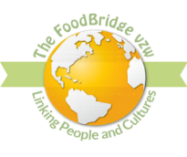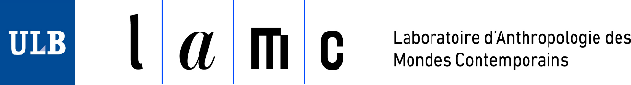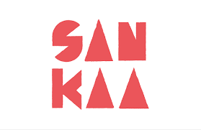
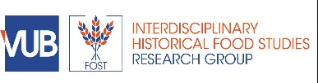

Programme
Conference; Decolonization, Diaspora and the African Food Systems
2nd to 3rd July 2024
Africa Museum Tervuren, Belgium

8.30 – 9.30 Welcome & Registration
9.30 – 9.40 Welcome Remarks by Dr Maureen Duru & Dr Sarah O’Neill
9.45 – 10.25 Keynote by Prof Adams Bodomo, Head of African Studies Department University of Vienna, Austria
Theme: "Where is African Agency in the African Diaspora Food Systems?"
10.30 – 11. 15 Breakout session “What do you understand by decolonizing the African food system?”: Followed by interactive discussions
11.15 – 11.30 Coffee Break
11.35 – 12.40 Precolonial and colonial African foodways
- Birgit Ricquier - Early Foodways in Northeast Congo: Shots of History Distilled by means of Comparative Linguistics
- Iradukunda M Tema - La nutrition à l’africaine, le Sorgho aliment traditionnel burundais
- Karina Ramos - The relationship between food consumption and territoriality in Luanda's colonial urban space (1949-1973)
- Maud Devos - Stilled objects versus cultural histories. Reconnecting museum objects related to coffee and cassava to past and present Tetela vocabularies.

12.45 – 13.30 Diaspora Foodways
- Michael Abwami Innocent - Exploring The Influence Of African Diasporas On Food Practices: A Development Communication Perspective
- Jahlani Niaah, Nicole Plummer, Sonjah Stanley Niaah - Decolonizing the Palate: Rastafari's Evolution of Ital Nutrition
- Philip Umaru, Azubuike Erinugha - Exploring African Food in Contexts: Implications for Diasporic Communities
- Sarah O’Neill & Maureen Duru – Mapping the African Food legacy in Belgium: the Vyakulani Project

      - Lunch – Chef Alagie, Banjul Kitchen

14.20 – 15.10 Economic Empowerment and Entrepreneurship
- Sarah De Smet, Smaranda Boros, Charlene Zietsma, Karijn Bonne and Claire Maréchal - Women immigrant entrepreneurs in Belgium: Strategies to belong
- Kennedy Oyier Ngoko- Sustainable Smart Aquaculture: Decolonizing African food systems for Economic Empowerment and Entrepreneurship
- Suzanne Awung, Founder Suzy Farms Corp Cameroon
- Farai Gwelo – Corporate control and small holder farmer’s autonomy in the digitalization of smallholder agriculture in South Africa
- Eduardo da Silva Oliveira: Decolonising Sustainability: Implementing Divergent Pedagogies for African-Centred Business Sustainability Management Solutions

15.15 – 15.45 Coffee break and nutritious food cooking demonstration
- Chef Alagie, Banjul Kitchen

  - – 17.30 African Diaspora food in literature
A workshop with Prof Adams Bodomo and other African authors

DAY TWO

8.30 – 9.25 Welcome & Registration
  - – 10.45 Health and Nutrition -
- Emiel de Meyer - Medicinal plant use among the Congolese (Democratic Republic of Congo) community in Belgium
- Laura Van Damme - Plant use and perceptions in the context of sexual health among people of Congolese descent in Belgium
- Helen Bour, Sandra Boatemaa Kushitor, Karina Benessaiah, Elena Bennett, Oonsie Reinette Biggs, Nyasha Magadzire - The Role Of Seeds In Transforming Food Systems In Coastal Areas In Ghana
- Food as medicine and heritage – Dr Stella Iwuagwu

10.50- 11.20 Side activity

- From Congo to Belgium: culinary journeys and stories
Du Congo à la Belgique : voyages culinaires et histoires
Césarine Sinatu Bolya
Valérie Maluma
- Pathy Kibungu
Mama Marie

11.25 – 11.40 Coffee Break

11.45 – 13.00 Food Sovereignty and Climate change
- Nicole Plummer, Marisa Wilson, Charmaine McKenzie, Inna Yaneva-Toraman, Thera Edwards, Patricia Northover, Sylvia Adjoa Mitchell, Anthony Richards, Kasikeiani Ronalda Pairman - Achieving Climate Justice Through a Decolonized Approach to Food Heritage
- Ndidi Nwaneri - ONUNAKA FARMS – 2021-2023
- Jutta Kleber - Relying on indigenous knowledge for sound agriculture, food and health systems - experiences from East-Africa

13.05 – 13.45 Lunch - Chef Alagie, Banjul Kitchen Food Truck

13.50 – 14.40 Food Policy and Governance
- Marthe Djuikom - Politiques de développement et mutations en milieu rural africain
- Aya Kasasa - Diaspora Desk, Organization of Africa, Caribbean and Pacific States (OACP)
- Guggi Laryea - International Fund for Agricultural Development (IFAD)

14.45 -15. 50 Panel Discussion “what is the Future of African Food Systems”
moderated by Ms Paddy Siyanga
- Ms Bwalya Mwali – Founder- Africa Tales, an initiative focusing on documenting and making Oral African history & traditions easily accessible and Networking for Africa, a platform for black professionals and Entrepreneurs.

Sven Bullaert – founder Umu BV including UMU Homes & Pods; building sustainable and healing homes that focus on the environmental and personal impact

and Herbie Chocolate; Belgian chocolate produced with traditional African and Asian herbs.

- Professor Adams Bodomo , Professor and Chair African studies University of Vienna Austria.
- (TBC 1)

15.55 – 17. 20 Vote of thanks and networking

