

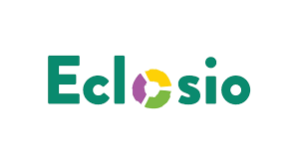

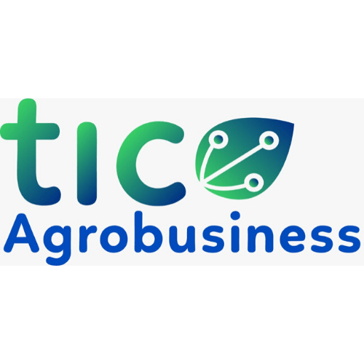



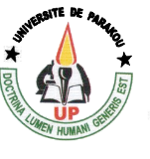

**Webinar**

**AGriCef, A digital solution for more effective and efficient agroecological management of the Fall Armyworm (FAW) in Northern Benin : Experience of the DigiCLA project**

**Concept Note**

**1. Background and rational**

In sub-Saharan Africa, maize, cultivated on approximately 37 million hectares, represents an essential activity for 98% of small family farmers, which constitutes the basis of the population feeding and nutrition (FAO, 2018). This crop is also of capital importance in animal feed (cattle, pigs, poultry, etc.). In Benin, maize dominates cereal production, totaling 70% of the volume produced (Ministry of Agriculture, Livestock and Fisheries [MAEP], 2019). However, the appearance of the Fall Armyworm (FAW) in 2016 caused significant damage, threatening food security, the local economy, and the trade balance of farmers (INRAB/FAO, 2024). This problem is even more worrying as pesticides prove to be ineffective and expensive, jeopardizing the profitability of small farms, the health of users and the environment (FAO, 2017). Thus, agroecological methods, supported by digital agriculture, are emerging as sustainable solutions (Barett and Rose, 2022; Maurel and Huyghe, 2017; Ajena et al., 2022).

In this context, the DigiCLA project is implemented by a consortium which includes the University of Parakou (UP), through the Research Laboratory on Innovation for Agricultural Development (LRIDA ), the NGO Eclosio and the startup company TIC Agro Business Center (TIC ABC). The DigiCLA project aims at promoting the adoption of digital and agroecological practices by young maize producers in northern Benin in the fight against FAW. Funded under the “Accelerating inclusive green growth through agro-industrial digital innovation in West Africa (AGriDI)” program, this project falls under ECOWAS regional priorities and priority area 1 (Consolidation of food and nutritional security in a context of climate change) of the Strategic Development Plan of the Agricultural Sector (PSDSA 2017-2025) PSDSA 2017-2025 of Benin.

After two years of implementation, different experiences have emerged, offering valuable potential learning for policy makers, development, and research stakeholders and technical and financial partners (PTF). Lessons learned from this initiative could contribute to enrich agricultural policies and development strategies, emphasizing the importance of digital agriculture and agroecological approaches to address the current challenges of the agricultural sector in Benin and the entire West African region.

**2. Objectives**

This webinar aims at sharing experiences and lessons learned from the DigiCLA project in Benin in terms of digital agriculture and agroecological management of CLA in the context of small producers. It will also discuss the opportunities and challenges encountered in the implementation of such initiative and explore prospects for the promotion of digital agriculture in the Beninese agricultural sector.

The webinar will cover the following points:

* **Developing tailored digital solutions**: we will explore in detail the design and delivery of digital solutions specifically tailored to the culture and information needs of farmers. We will highlight the development processes of digital tools, focusing on their accessibility, user-friendliness, and relevance for end users, while considering the local agricultural context.
* **Promotion of agroecological practices**: we will present the agroecological practices promoted by the project and examine the process which made it possible to evaluate their reliability and effectiveness. We will discuss methods of disseminating these practices to the field, highlighting their positive impact on agricultural productivity, environmental sustainability, and the resilience of agricultural systems to challenges such as FAW.
* **Knowledge management**: project implementation relies on good management of digital and agricultural knowledge. We will present the processes put in place to ensure the exploration, mobilization and exploitation of the knowledge required to support producers in the fight against the fall armyworm.

**3. Methodology**

The webinar will be organized and moderated by three panelists, each responsible for presenting one of the points indicated above. The panelists are the main managers of the member institutions of the consortium involved in the project, namely the Director of TIC ABC, the Coordinator of the NGO Eclosio and the Director of LRIDA (University of Parakou). Each of them will address a specific theme corresponding to one of the objectives of the project:

* The Director of TIC ABC will present digital solutions adapted to the needs and context of farmers.
* The Coordinator of the NGO Eclosio will discuss inclusion in the identification and scaling of effective agroecological practices.
* The Director of LRIDA will address the partnership dimension of the project and coordination between the different actors.

**4. Expected outputs**

The expected results of this webinar are as follows:

* Increased understanding of tailored digital solutions: participants will have a better understanding of how digital solutions have been developed to meet the specific needs of farmers, with a focus on their accessibility and utility in the agricultural context of Benin.
* Appreciation of agroecological practices: participants will be able to understand the principles and benefits of agroecological practices promoted by the DigiCLA project, as well as the evidence of their effectiveness and sustainability.
* Insight into the coordination of project stakeholders: participants will gain an overview of the coordination and collaboration mechanisms between the different project stakeholders, which will allow them to learn lessons on good practices in the management of multi-stakeholder actors.
* Identifying collaboration opportunities: the webinar will provide participants with the opportunity to identify collaboration opportunities with DigiCLA project stakeholders, whether through partnerships, funding, or knowledge sharing.
* Inspiring agricultural innovation: by showcasing the experiences and successes of the DigiCLA project, the webinar will inspire participants to explore new approaches and technologies to improve agriculture in Benin and other similar regions.

**Participants**

Ce webinar is opened to stakeholders from research communities, industry and policy actors of agriculture sector and ICT.

**6. Schedule**

This webinar will take place on **April 18, 2024**, for two (02) hours, from **8:00 Cotonou** time, **7h GMT** or **10:00 East Africa** Time, following the schedule presented below.

|  |  |  |
| --- | --- | --- |
| Timing | Activity | Responsable |
| 08h00-08h10 | * Introduction to the webinar * Introduction of panelists | Moderator  Panelists |
| 08h10-08h20 | Digital solutions adapted to the needs and context of farmers | Directeur de TIC ABC |
| 08h25-08h35 | Inclusion in the identification and scaling of effective agroecological practices | Coordonnateur ONG Eclosio |
| 08h40-08h50 | Knowledge management | Coordonnateur Projet DigiCLA |
| 08h55-09h55 | Discussions on communications | Panélistes et audience |
| 09h55-10h00 | Summary and final words | Moderator |

**7. Conclusion**

This webinar offers a unique opportunity to share knowledge, exchange experiences and catalyze concrete actions to promote digital agriculture and agroecology. By bringing together diverse stakeholders from the agricultural sector, it will help strengthen efforts to positively transform agricultural practices and ensure sustainable food security in the region.

**8. Références bibliographiques**

Ajena, F., Bossard, N., Clément, C., Hibeck, A., Tiselli, E., & Oehen, B. (2022). Agroecology & Digitalisation: traps and opportunities to transform the food system. <https://www.organicseurope.bio/content/uploads/2022/06/IFOAMEU_Agroecology_Digitalization_2020.pdf?dd>

Baco, N. 2011. Caractérisation des ménages producteurs de maïs en zone de savane sèche au Bénin. Ibadan : IITA.

Barrett, H., & Rose, D. C. (2022). Perceptions of the fourth agricultural revolution: what’s in, what’s out, and what consequences are anticipated? *Sociologia Ruralis*, *62*(2), 162-189. <https://doi.org/10.1111/soru.12324>

FAO, 2017. Gestion durable de la chenille légionnaire d’automne en Afrique : Programme d’actions de la FAO. Rome. <http://www.fao.org/3/i7861f/i7861f.pdf>

FAO, 2018. Présence de la chenille légionnaire d’automne en Afrique : situation, risques et mesures à l’échelle mondiale. Vingt-sixième session. Rome, 1er-5 octobre 2018

FAO, 2024. Un projet de la FAO pour lutter contre la chenille légionnaire au Bénin. <https://www.fao.org/benin/actualites/detail-events/zh/c/1103005/>

MAEP, 2019. Stratégie nationale pour l’e-Agriculture au Bénin 2020-2024

Maurel, V. B., & Huyghe, C. (2017). Putting agricultural equipment and digital technologies at the cutting edge of agroecology. *Ocl*, *24*(3), D307. <https://doi.org/10.1051/ocl/2017028>



Kindly register ahead the webinar using the below link.

[https://us02web.zoom.us/meeting/register/tZwtce-trT0qHNefE8buv08iZqG-8jv8JdeE](https://eur02.safelinks.protection.outlook.com/?url=https%3A%2F%2Fus02web.zoom.us%2Fmeeting%2Fregister%2FtZwtce-trT0qHNefE8buv08iZqG-8jv8JdeE&data=05%7C02%7Cjmugabe%40icipe.org%7C81e64ea76c674e2d7a0f08dc54a3c62a%7Ca4e98fb557d94b97b7b260ab87e9a234%7C0%7C0%7C638478309593078554%7CUnknown%7CTWFpbGZsb3d8eyJWIjoiMC4wLjAwMDAiLCJQIjoiV2luMzIiLCJBTiI6Ik1haWwiLCJXVCI6Mn0%3D%7C0%7C%7C%7C&sdata=XLZeGRbCg4ySmbnzu5mGH3Ju4YADPDRrBJ%2BQnVCmcZE%3D&reserved=0)